OPTIMAL STOCHASTIC DYNAMIC CONTROL OF SPATIALLY DISTRIBUTED INTERDEPENDENT PRODUCTION UNITS

Peter Lohmander

Peter Lohmander Optimal Solutions and Linnaeus University, Hoppets Grand 6, 903 34 Umea, Sweden, [Peter@Lohmander.com](mailto:Peter@Lohmander.com)

Abstract

Stochastic dynamic programming, SDP, is often the optimal method. SDP can be extended to handle very large dimensionality in the decision space, as long as the dimensionality of the state space is not too large, since SDP can be combined with linear or quadratic programming subroutines for every state and stage. When the number of decision variables is large and the optimal decisions are dependent on detailed information in a state space of large dimensionality, SDP cannot be applied. Then, optimal control functions for local decisions may be defined and the parameters can be determined via stochastic full system simulation and multidimensional regression analysis. This paper includes an approach to determination of all local decisions based on locally relevant state space information within stochastic dynamic and spatially explicit production. The expected present value of all harvests, over time and space, in a forest area, is maximized. Each tree is affected by competition from neighbor trees. The harvest decisions, for each tree, are functions of the price in the stochastic market, the dimensions and qualities of the individual trees and the local competition. The expected present value of the forest is an increasing function of the level of price risk.

3.5cm

3.5cm

Keywords: Stochastic dynamic control, spatial optimization

1 Introduction

2.5cm

The ambition of this study is to develop a general method for optimization of stochastic and dynamic decision problems with spatial dependencies that cannot be neglected and where the need to use a multidimensional state space in high resolution makes it computationally and economically impossible to apply the otherwise relevant method stochastic dynamic programming. Applications can be found in most sectors of the economies. One of the most obvious cases, where useful and statistically estimated functions already exist, is the forest sector. We start with a forest area with 1000 trees of different sizes, as shown in Figure 1. The initial locations and sizes of the trees are simulated.

2.5cm

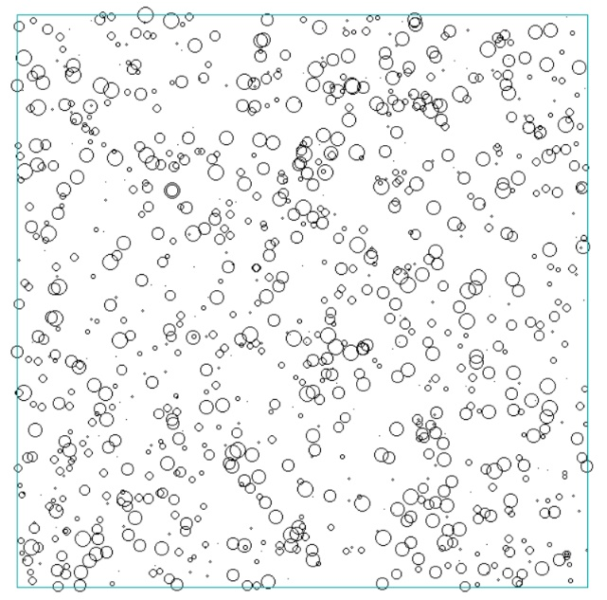

Figure 1: Spatial map of initial conditions at t = -1 (years from the present time). The locations of the circle centers are the locations of the trees. The circle diameters are proportional to the tree diameters. The square represents one hectare (100m*100m).

The problem is to determine an adaptive control function to be used in this forest, giving the maximum of the total expected present value of all activities over time. The annual increment of each tree is a function of tree size and competition from neighbor trees. The different trees have different wood qualities, initially randomly assigned to the individuals. The market value of a tree is a function of size, quality and stochastic price variations. The variable harvesting cost of a tree is size dependent. Every five years, the trees in the forest are inspected. Then, depending on market prices, tree sizes, competition, quality etc., it is possible that some or many trees are harvested. The optimized control function is used to make all of these decisions. Figure 2 shows the structure of the forest directly after optimal harvesting at t = 0. Obviously, a considerable number of large trees have been removed. Many new seedlings are however found on the land, in random positions. The trees continue to grow and Figure 3 illustrates the situation 35 years later. 69 years after the first harvest, trees of considerable sizes exist (Figure 4). The total number of large trees in year 69 is however much lower than before the harvest during year 0. Several large trees are harvested in year 70 (Figure 5). This type of stochastic dynamic and spatial forest development is sustainable. Furthermore, there are always trees in the forest. We have a system of “optimal continuous cover forestry”.

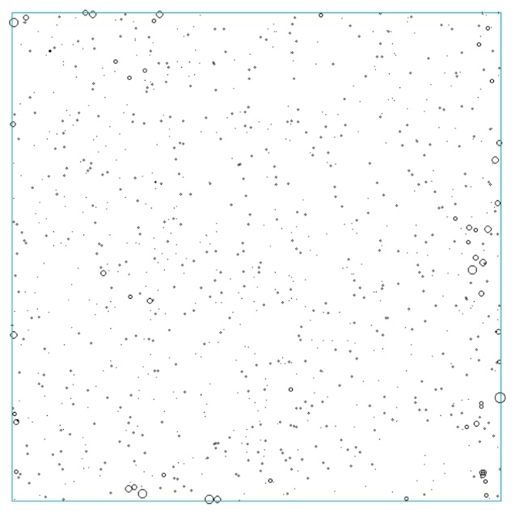

Figure 2: The state after the first application of the optimized control function at t = 0. Most of the largest trees have been removed.

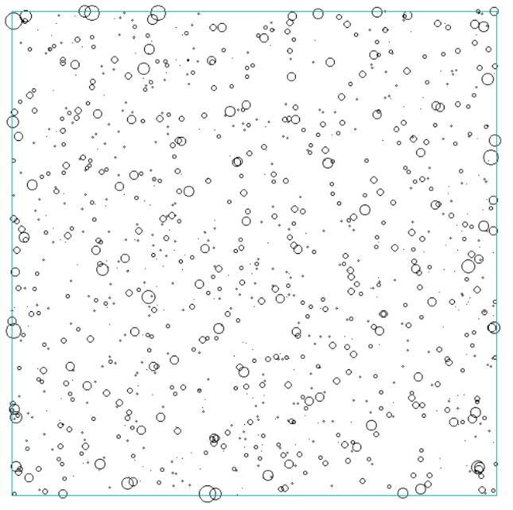

Figure 3: The forest at t = 35.

Lohmander [1] describes several alternative methods to optimize forest management decisions at higher levels. Lohmander and Mohammadi [2] determine optimal harvest levels in beech forests in Iran, using stochastic dynamic programming. Then, however, the tree selection decisions were never analyzed.



Figure 4: The forest at t = 69.



Figure 5: The forest at t = 70.

2 Analysis

The optimal decisions for each tree, i, at time t, is determined by the diameter limit function. If the diameter is larger than the diameter limit, then the tree should be harvested. Otherwise, it should be left for continued production.



The parameters  are optimized in this study. In the graphs and software, they are denoted (dlim_0, dlim_c, dlim_q and dlim_p).

 denote competition index for tree i, quality of tree i and the stochastic deviation of the market price from the expected price, at time t. The stochastic price deviations are i.i.d. and have uniform pdf on the interval -10 to +10 EURO/cubic metre.

The objective function is the total expected present value of all revenues minus all costs from year 0 until year 200. The real rate of interest is set to 3%. The computer model includes functions for tree height as a function of diameter, functions used in tree volume calculations, set up costs, tree size dependent revenues and variable harvesting costs etc.

The trees grow according to a modified version of the function reported by Schütz [3]. The modification is that in [3], competition is assumed to come from all parts of the forest area, also far away from the individual tree. In the function applied in this new analysis, only competition from trees at distances ten meters or closer, is considered. Furthermore, in the Schütz function, each tree is only affected by competition from trees with larger diameters. In the present study, also competition from trees with smaller diameters is considered. However, it is probably the case that trees with smaller diameter give a lower degree of competition. The motivation for the new function, used here, is that competition for light, water and nutrients, obviously is stronger from neighbor trees than from trees far away. Furthermore, also smaller trees use some of the available light, water and nutrients.  is now expressed as the basal area per hectare of larger competing trees plus the basal area of smaller competing trees divided by 2 (all within the 10 meter radius circle). In future studies, the competition function should be estimated with locally relevant data.



 is the diameter increment of tree i and  is the diameter.  is a set of empirically estimated parameters, published by Schütz [3], for beech in Germany.

The optimization of the total expected present value, via the parameters of the adaptive control function, contained the following steps: A software code was constructed and tested in QB64. The objective function was estimated for a set of combinations of the control function parameters. For this purpose, a four dimensional loop with alternative parameter values was run. Preliminary iterative studies were first made to determine interesting parameter intervals. Then, a 3*3*3*4 loop was used, which gave 108 parameter combinations. For each parameter combination, the total expected present value during 200 years was estimated for 10 different forest areas of one hectare, each with 1000 initial random trees. That analysis took approximately 8 hours on an Acer Aspire V personal computer with an Intel Core i5 processor. Next, the parameter values of  determined in the “108-loop”, were considered optimal and fixed. A more detailed analysis, with higher resolution, of the parameters  was made.

3 Main Results

The adaptive control function parameters  were determined in a general loop. 108 combinations were evaluated. This is the adaptive control function:



The optimal objective function value was estimated to 2571 EURO/hectare. Next, the parameter values of  determined in the “108-loop”, were considered optimal and fixed. A more detailed analysis, with higher resolution, of the parameters  = (dlim_0, dlim_p) was made. Figure 6 shows the objective function and in Figure 7, the objective function level curves are given.

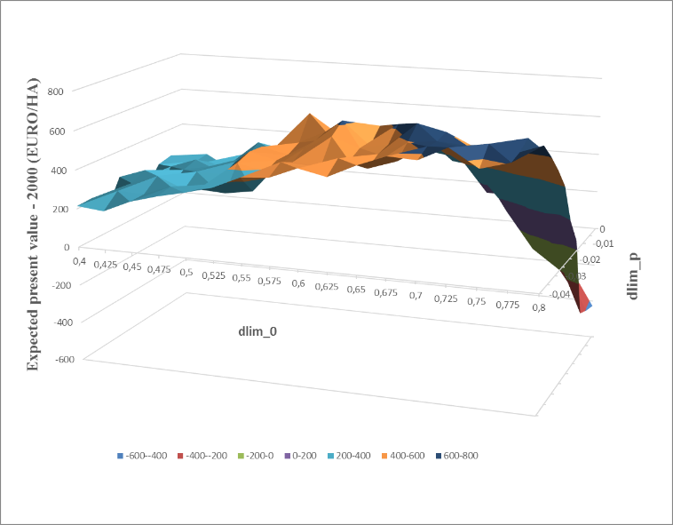

Figure 6: The objective function reduced by a constant as a function of the parameters dlim_0 and dlim_p, for optimal values of the other parameters, namely dlim_c = -0.003 and dlim_q = 0.02.

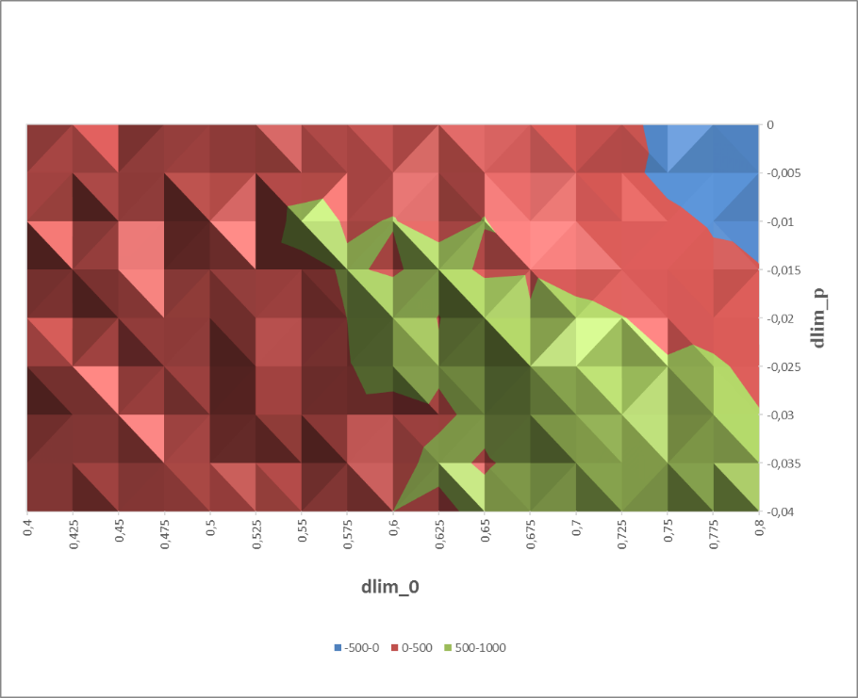

Figure 7: The level curves of the objective function as a function of the parameters dlim_0 and dlim_p, when the other parameters were held constant at their optimal values.

Multiple regression analysis and the data presented in Figure 6 were used to estimate a quadratic approximation of the objective function, Z. Let (x, y) =.



The R2 value of the regression was 0.999 and all coefficients were statistically significant, with p-values below 0.00003. The first order optimum conditions are:





The equation system  gives this unique solution:

. Now, the objective function value is 2690 EURO/hectare.

The derived optimum is a unique maximum, which is confirmed by:

 and 

The quadratic approximation gave this control function:



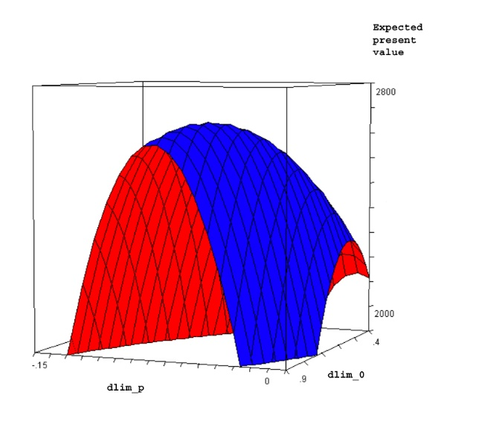

Figure 8: The objective function as a function of the parameters dlim_0 and dlim_p, according to the quadratic approximation, when the other parameters were held constant at their optimal values.

ACKNOWLEDGEMENTS. Thank you FORMAS for travel funding.

References

[1] Lohmander, P., Adaptive Optimization of Forest Management in a Stochastic World, in Weintraub A. et al (Editors), Handbook of Operations Research in Natural Resources, Springer, Springer Science, International Series in Operations Research and Management Science, New York, USA, pp 525-544, 2007

[2] Lohmander, P., Mohammadi, S., Optimal Continuous Cover Forest Management in an Uneven-Aged Forest in the North of Iran, Journal of Applied Sciences 8(11), 2008

[3] Schütz, J-P., Modelling the demographic sustainability of pure beech plenter forests in Eastern Germany, Ann. For. Sci. 63 (2006) 93–100