Optimization of adaptive control functions in multidimensional forest management via stochastic simulation and grid search

Peter Lohmandera*

a*Professor Dr., Optimal Solutions & Linnaeus University, Sweden

Abstract

A dynamic multidimensional production system, with several interdependent processes, is adaptively controlled under the influence of stochastic market changes. An adaptive control function with low dimensionality that makes it possible to directly and indirectly control all parts of the interdependent processes is determined. Discrete parameter value combinations are investigated. Grid search is applied to find optimal control function parameter values via stochastic simulation, where the complete production system is simulated 100 times, during 200 years. The 100 time series of random numbers, each representing 200 years, used to represent stochastic market changes, are the same for every control function parameter combination. The optimal control function is determined for beech stands in Germany, as an adaptive harvest diameter rule, for different rates of interest and for different levels of market risk. With a discrete approximation of a uniform price probability density function with price variation within the interval -40 to +40 EURO/m3, 3% rate of interest and optimal control, the expected present value was 62% higher than without risk. Without risk the optimal harvest diameter was 55 cm and with risk, 115 – 2cm, where denotes wood price deviation in period t from the average wood price (EURO/m3).

Keywords: Adaptive control function; Stochastic system optimization; Forest management.

# 1- Introduction

Many real world optimization problems concern management of systems under risk with large numbers of dimensions. Stochastic dynamic programming is a highly relevant method in most cases, but the dimensionality problem makes it practically impossible to really deal with the system in high resolution. Similar approaches have been used to optimize adaptive control functions also in other forest sector relevant applications. Lohmander [2] and [3], developed software and solutions for continuous cover forest management in Sweden, using a logistic stand level forest growth function. It was possible to determine the optimal harvest level as a function of current price and current stock level. This way, forest management could be optimized and the expected present value maximized. The optimal control function parameters and expected present value were determined for different rates of interest and for different levels of risk. Later, Lohmander and Mohammadi [7], analysed a similar problem with forest data and prices from Iran, using discrete time stochastic dynamic programming, with the methodology described in Lohmander [6].

Lohmander [4] has shown that it is possible to use the method described in this paper also to solve forest industry company problems, where decisions concerning storage levels, industrial production, sales volumes and industrial production capacity investments are integrated in the analysis. Lohmander [5] demonstrated how the same basic method can be used to control trucks and roundwood logistics, taking the changing conditions in forest industrial plants such as saw mills and pulp mills into account. In the adaptive control function, individual truck drivers instantly obtained optimal driving, loading and unloading instructions, based on current product prices, present position(s) of the individual truck(s) and the amount of roundwood already loaded on the truck(s) and the current positions and stock levels at all industrial plants.

* Corresponding author: *E-mail address*: Peter@Lohmander.com

The approach used in this analysis makes it possible to let the complete system dynamics be treated correctly, as described by the dynamic equations. At the same time, adaptive control functions can be developed, that optimize the system behaviour under the influence of stochastic processes such as market changes etc..

The general method is the following:

A dynamic multidimensional production system, with several interdependent processes, is adaptively controlled under the influence of stochastic market changes. An adaptive control function with low dimensionality that makes it possible to directly and indirectly control all parts of the interdependent processes is determined. In the forest management application developed here, the adaptive control function determines the lowest diameter of trees that should instantly be harvested. In classical forest management planning, such a “limit diameter” is usually determined as a constant, which is applied irrespective of changes in market prices etc.. Now, in the present analysis, we let the limit diameter be a function of this type:

(1) 

denotes “limit diameter” at time t, and  are parameters that should be optimized and is the stochastic market price deviation from the average market price in period t.

# 2- Analysis

The optimal control function was determined for beech stands in Germany, as an adaptive harvest diameter rule, for different rates of interest and for different levels of market risk. The empirical background to the conditions in these forests and estimated growth processes for trees in different diameter classes were reported by Schütz [8]. One important reason why this optimization problem has to be considered as multidimensional, is that the growth of trees in different diameter classes are not independent. For this reason, it is impossible to handle the harvesting decisions in different diameter classes as independent of each other, in order to reduce the number of dimensions. The central principle, empirically estimated by Schütz [8], is that the growh of trees in a particular diameter class is negatively affected by the total basal area of all other trees in larger diameter classes. According to Schütz [8], this dependence is strongly negative and the functional form is cubic.

The dynamical model contains many functions, parameters and detailed assumptions that are impossible to describe in full detail in this short paper.

Some of the particularly interesting and important functions are these:

(2) 

The parameters are: 

denotes the diameter increment per year of trees in diameter class. The values of , for different  values, changes dynamically over time as a function of the developments of number of trees in the diameter classes larger than . is the average diameter before increment of trees in diameter class. is a function describing the degree of competition for resources such as sunlight, water and nutrients via the root system, from larger trees.  is defined as the total basal area per area hectare of trees with diameter larger than . We observe that  is large for small trees and small for large trees. Equation (2) shows that the diameter increment is negatively affected by. This fact makes the development of trees in different diameter classes dependent on each other and it also means that the management decisions of trees in one particular diameter class cannot be optimized without considering the direct and indirect effects on the trees in other diameter classes. The diameter increment functions (2) for the different diameter classes determine the probabilities that trees in different diameter classes move up the next diameter classes. The expected number of new trees that each period will appear as a result of natural regeneration, in the lowest diameter class, is a topic of special interest. This is discusses and analysed in detail by Schütz [8].

We may summarize the dynamical model this way:

(3) 

denotes the number of trees per hectare in diameter class in period .

is the probability for trees in diameter class to move up to the higher diameter class in period .

denotes the number of trees harvested (via optimal control) of trees in diameter class in period .

Of course,  is a function of , described in (2).  is a function of the adaptive control parameters found in (1), the random development of the exogenous market conditions and the dynamically changing availability of trees in different diameter classes.

Note that the adaptive control function (1) introduced in the present analysis indirectly controls the dynamics of trees in all diameter classes. If the market price increases, the limit diameter decreases. As a result, more trees in the larger diameter classes are removed. Then, the competition is reduced for all trees in lower diameter classes and they will grow more. Discrete control function parameter value combinations were investigated. Grid search was applied to find optimal control function parameter values via stochastic simulation, where the complete production system was simulated 100 times, during 200 years. The 100 time series of random numbers, each representing 200 years, used to describe stochastic market changes, were the same for every control function parameter combination. As one could expect, with stochastic prices, it turned out that the optimal values are: . The precise values are functions of all parameters in the problem. This means that we should harvest more if prices are high than if they are low, since the limit diameter is reduced as a function of high prices.

## 3 Results

In Figure 1. we find the expected present value without risk as a function of harvest diameter and interest rate. The optimal harvest diameter, equal to the limit diameter, is a decreasing function of the rate of interest. Furthermore, the optimal expected present value is a decreasing function of the rate of interest.

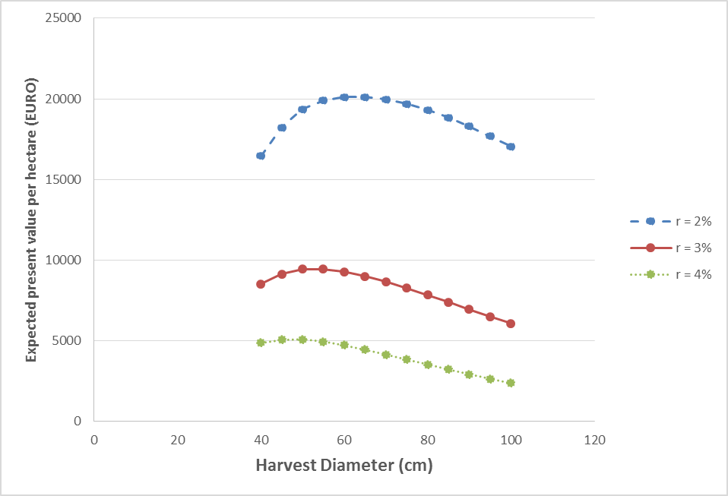

Figure 1.

The expected present value per hectare under risk as a function of adaptive control function parameters is shown in Figure 2. For the rate of interest 3%. The optimal values of the parameters are = ALFA = 115 and = BETA = -2.

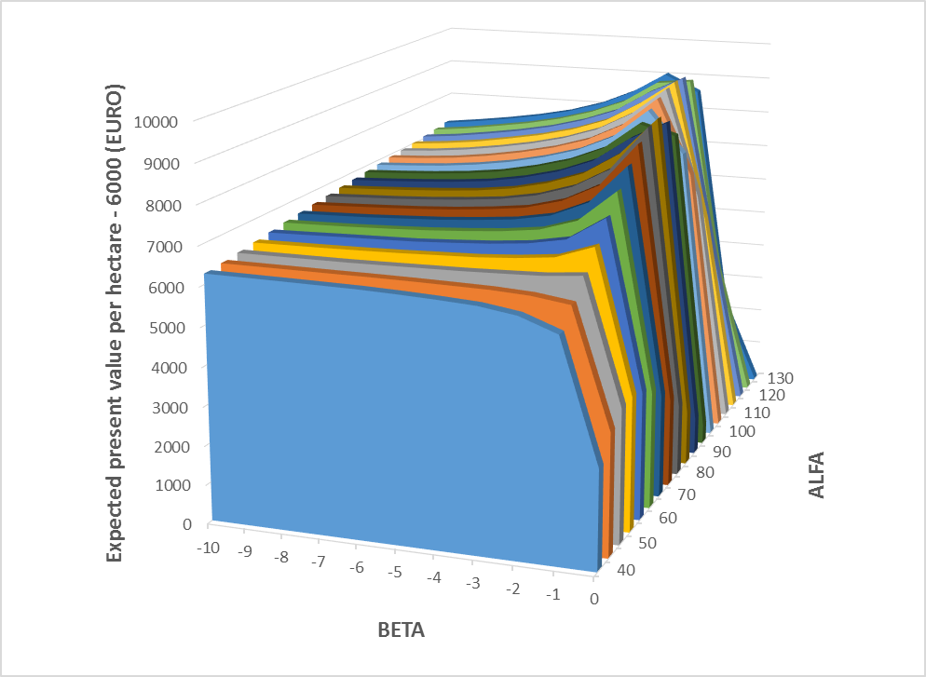

Figure 2.

With a discrete approximation of a uniform price probability density function with price variation within the

interval -40 to +40 EURO/m3, 3% rate of interest and optimal control, the expected present value was 62% higher than without risk. Without risk, the optimal harvest diameter was 55 cm and with risk, 115 – 2cm, where denotes wood price deviation from the average wood price (EURO/m3).

In Figure 3., the optimal adaptive control function under risk, namely the market price dependent optimal limit diameter function, is plotted. The function is based on the control function parameters that gave the highest expected present value according to Figure 2. Figure 2. also contains the optimal limit diameter function without risk, which is constant, also found in Figure 1. It is interesting to note that, under risk, the limit diameter is much higher than without risk, in case we have an average market price (Stochastic price deviation = 0). The price has to be much higher than the average price, about 30 EURO/m3 higher in this case, if we should harvest trees of the same size under risk and certainty. According to the model assumptions, the stochastic price deviation has a uniform probability density function with support on the interval -40 and +40 EURO/m3. Hence, the probability that the price deviation is higher than 30 EURO/m3 is 1/8 or 12.5%. So, if a tree has diameter 55 cm, we should harvest it with 12.5% probability if there is market risk. We should wait at least one more year with probability 87.5%. If the price is more than 30 EURO/m3 higher than the average market price, we are ready to harvest trees that are smaller than what is optimal without market risk. This type of effect of market price risk on optimal management is what we should expect to find in problems of his type. The precise values found in Figure 3. are however only relevant in the particular example.

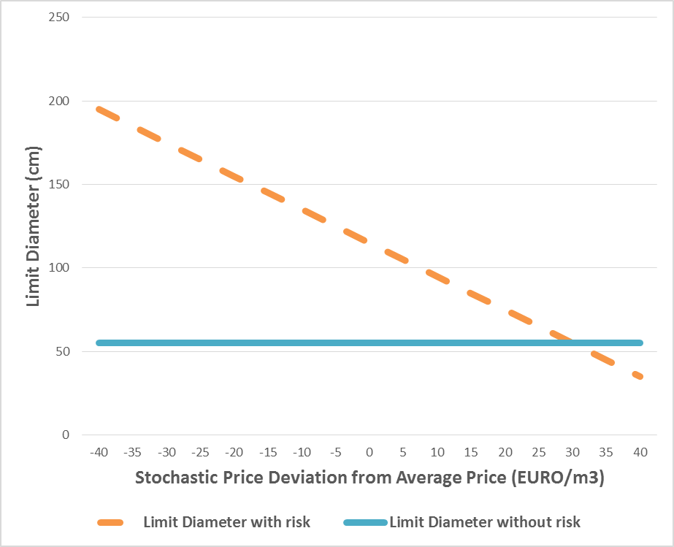

Figure 3.

# 4- Conclusion

It is possible to use the described method to improve the control of large stochastic systems of very different kinds. In many cases, there are no alternative approaches available that can solve the relevant problems in reasonable time. The concrete numerical results presented in this study should be considered as illustrations of what is possible to derive in similar problems. The numerical results are affected by many model details that are not possible to describe and motivate in detail in this short paper. One of the important modelling topics that is fundamental to work of this nature is definition and estimation of stochastic processes representing market prices and other stochastic disturbances of particular application relevance. In Lohmander [1], we find that alternative specifications of price processes and damage probability functions can lead to drastically different types of optimal resource control functions. For instance, autocorrelation functions and stationarity are important concepts to consider and estimate before detailed resource control models are developed and solved. In the present analysis, stationary and independently distributed market prices were assumed in all periods. Of course, in other cases, the process properties may be different. Furthermore, expected prices minus costs for harvesting and terrain transport in different size classes, were assumed to follow a diameter dependent net price function. The reader should be aware that future use of this approach requires familiarity with such functions and that the final model has not yet been constructed. Several examples of stochastic price processes in the round wood markets have been described and analysed in Lohmander [1]. In Finland, Sweden and Norway, these prices could be described as stationary first order autoregressive processes. In future applications of the optimization method described in this paper, it is suggested that the relevant price process parameters are first estimated from available historical tables and that the simulations of the 100 random price series is based on these parameters. It is also important to be aware of the fact that historical price series data are not always relevant to analysis of optimal decisions, at the present and in the future. New technologies, new demand structures and new discoveries of natural resources may change the fundamental structures and parameters also of stochastic market price processes. Relevant analysis has to explicitly take these things into account.

### Acknowledgment

The author is grateful to Prof. Dr. Jean-Philippe Schütz, ETH, Zürich, Switzerland. The forest growth difference equations from his article [8] were used in this optimization study. Furthermore, he showed me interesting experiments in Switzerland. Partial funding from FORMAS made this research possible.

### References

1. Lohmander, The economics of forest management under risk, Swedish University of Agricultural Sciences, Dept. of Forest Economics, Report 79, 1987 (Doctoral dissertation), 311p
2. Lohmander, P., Continuous harvesting with a nonlinear stock dependent growth function and stochastic prices: Optimization of the adaptive stock control function via a stochastic quasi-gradient method, Swedish University of Agricultural Sciences, Dept. of Forest Economics, No. 144, 1992, http://www.Lohmander.com/Lohmander_R144_1992.pdf
3. Lohmander, P., Continuous harvesting with a nonlinear stock dependent growth function and stochastic prices: Optimization of the adaptive stock control function via a stochastic quasi-gradient method, in: Hagner, M. (editor), Silvicultural Alternatives, Proceedings from an internordic workshop, June 22-25, 1992, Swedish University of Agricultural Sciences, Dept. of Silviculture, No. 35, 198-214, 1992, <http://www.Lohmander.com/Lohmander_SilvAlt_1992.pdf>
4. Lohmander, P., Decision optimization with stochastic simulation subroutines: Relation to analytical optimization of capacity investment and production, presented at the "4'th International Conference of Systems Analysis and Simulation 1992", SYSTEMS ANALYSIS - MODELLING - SIMULATION, Vol. 10, 279-314, 1993, <http://www.Lohmander.com/PL_SAMS_10_1993.pdf>
5. Lohmander, P., Optimization of decentralized adaptive truck decision rules: - A spatial dynamic stochastic forest company problem, paper presented at the "Natural Resource Management Cluster" of the TIMS/ORSA meeting, Los Angeles, April 23-26, 1995,and at the general meeting of Scandinavian Society of Forest Economics, Finland, 1996, in Saastamoinen, O. & Tikka S., (Editors), SCANDINAVIAN FOREST ECONOMICS, 36:, 73-87, 1997, <http://www.Lohmander.com/Lohmander_Adapt_truck_1995.pdf>.
6. Lohmander, P., Adaptive Optimization of Forest Management in a Stochastic World, in Weintraub A. et al (Editors), Handbook of Operations Research in Natural Resources, Springer, Springer Science, International Series in Operations Research and Management Science, New York, USA, pp 525-544, 2007
7. Lohmander, P., Mohammadi, S., Optimal Continuous Cover Forest Management in an Uneven-Aged Forest in the North of Iran, Journal of Applied Sciences 8(11), 2008
8. Schütz, J-P. (2006) Modelling the demographic sustainability of pure beech plenter forests in Eastern Germany, Ann.For.Sci. 63 (2000), 93-100, http://dx.doi.org/10.1051/forest:2005101