 Optimal forest management based on growth data from the Iranian Caspian forests

Peter Lohmandera, Soleiman Mohammadi Limaeib*, Leif Olssonc, Zohreh Mohammadid

aProfessor Dr., Optimal Solutions & Linnaeus University, Sweden

bAssociate Professor, Faculty of Natural Resources, University of Guilan, Sowmeh Sara, P.O.Box 1144, Iran

cAssociate Professor, Faculty of Sciences, Technology and Media, Mid Sweden University, Sweden

dPhD Student, Faculty of Natural Resources, University of Guilan, Sowmeh Sara, P.O.Box 1144, Iran

Abstract

Forest management in the Iranian Caspian forest is optimized via harvesting decisions based on individual trees. The theory of optimal control in discrete time, stochastic dynamic programming, is applied. The optimization program utilizes new basal area growth and volume functions for beech, estimated via data from the Iranian Caspian forest.

Recent information about the degree of price variation is used in the optimizations. The optimal control function is defined as a reservation price function, which is determined via backward recursion. The optimal reservation price function and the optimal expected present value function are determined for alternative levels of interest rate and risk. Furthermore, the optimal harvest year and optimal harvest diameter frequency distributions are determined for different degrees of risk and rate of interest.

Keywords: Stochastic dynamic programming; Optimal reservation price function, Harvest diameter probability distribution.

# 1- Introduction

Mathematical programming is the generally accepted term for a set of methods that can be used in the forest management planning in order to optimize the goals and overcome the constraints imposed by various influences (constraints due to specific forestry production) and conflicting interests [1].

It is explicitly accepted that there are conditions in the environment that can not be perfectly predicted. Environment here includes everything that is exogenous to the system which should be optimized. Furthermore, it is explicitly accepted that decisions can take place over time and that later decisions should be based on the best and latest information concerning the exogenous conditions. The tradition of long term planning in forestry is based on the assumption that long term predictions with high precision are possible. Here we can mention that the traditional forestry assumption is not rational. Timber prices are difficult to predict accurately, since many things may influence these markets as always when we are dealing with some sort of markets. The stumpage price fluctuates over time and it is very difficult to predict it (with high accuracy). Therefore we can regard the stumpage price as a stochastic process. Clearly, some other phenomena, such as the growth of the forest, may also be stochastic. Mostly, the price variation is the most important source of risk [2]. Market risks have also been studied a lot, for instance for financial markets, and is a well-known fact that the underlying factors make them one of the hardest to predict [3].

One question under investigation in this paper is whether or not the present harvest should increase or decrease under the influence of increasing risk in the stochastic price process.

The optimal forest harvesting decision problem is formulated as a stochastic dynamic programming problem in discrete time according to the principles described by Lohmander [4], [5] and [6]. Empirical data from the Caspian forest of Iran was used to estimate the basal area growth and volume functions used in the optimizations.

# 2- Materials and methods

## 2-2- Study area

This research conducted in district 16 at Shafaroud forest, Guilan province in northern Iran (Figure, 1). The study are altitude ranges 300m to 1200m, latitude ranges 37°32′ 30" to 37°31′ 50" and longitude 48°54′ to 49°2′. The total area is 1444 ha . In district No16, forest communities could be identified as follows:

*Fagus oreintalis*- *carpinus betulus*, *Parrotia persica – carpinus betulus, m*ixed broad leaf type, *Fagus oreintalis* with the other species type.

Four different classes of soils found at district 2 such as forest brown soils, brown soils, acidic brown soils and brown soils [7].

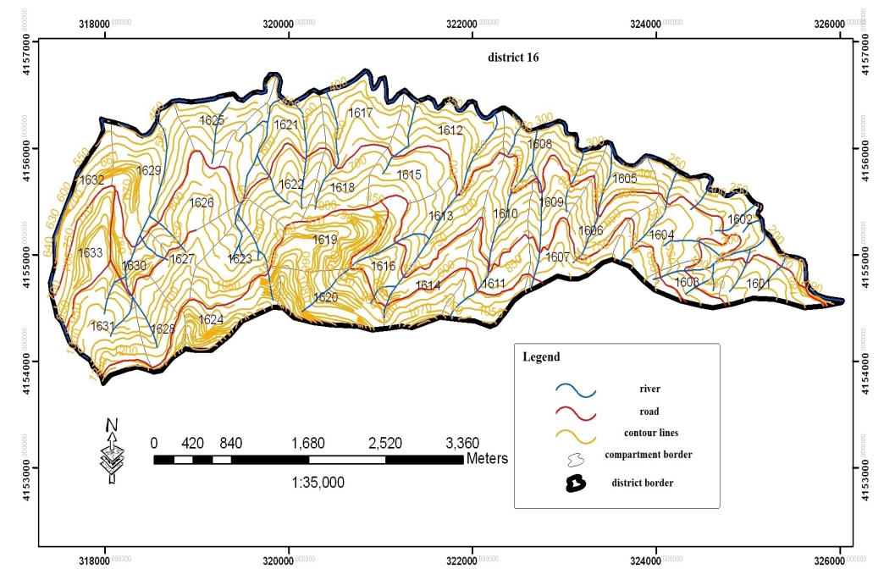

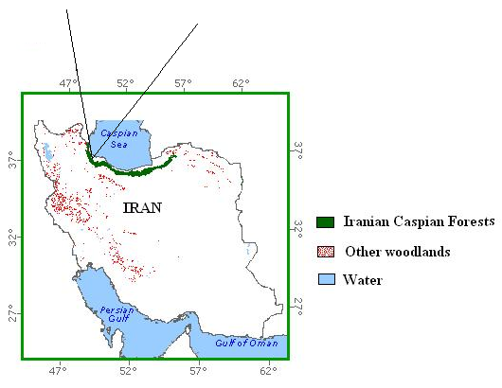

Figure 1: The study area. District 16, Shafaroud forests, north of Iran

## 2-2- Method

## 2-2-1- Data collection

Data such as volume per hectare, number of tree per hectare, diameter classes was collected from previous research [8]. Stumpage price was also collected from the Shafaroud Forest Company.

In the present study, the optimization concerns management decisions for beech trees. The reported functions are relevant to that species.

**2 -2-2- Mathematical principles**

The objective function is the expected present value at time t, . In each time period, you can select to harvest or to wait at least one more period. In case the stochastic price, , turns out to be lower than the optimal reservation price, , then you wait at least one more period before you harvest.

In case you harvest, you obtain, which is the discounted value of the price multiplied by the present volume plus the value of the land, .  is the probability density function of price in period t.

In equation (1), we find the expected present value, . We maximize via optimal selection of the reservation price, . Equations (2) – (9) show how we can derive the optimal reservation prices via backward recursion. The optimal reservation price function gives unique and optimal values of .

The recursion has to start at a point in time, the horizon, , sufficiently far away in the future. At that distant point in time, we let .

1. 

The first order optimum condition is:

1. 

We investigate the second order maximum condition:

1. 
2. 
3. 
4. 
5. 

We find that the optimum will be a unique maximum.

1. 

The optimal reservation price function is obtained this way:

1. 

Connected analyses and fundamental principles are derived and described in the references [4], [5] and [6].

The empirical estimations gave these functions. These functions were also used in the optimizations:

1. 

denotes the volume as a function of time andis the basal area function.

1. 

The parameter values of relevance to equations (10) and (11) are:



# 3- Results

Figure 2. shows the optimal reservation price as a function of time for the real rate of interest 2%. At time 0 we start with a tree in diameter class 40 cm. NR means ”No risk” and ”R” means that the real risk level of the Iranian market is considered.

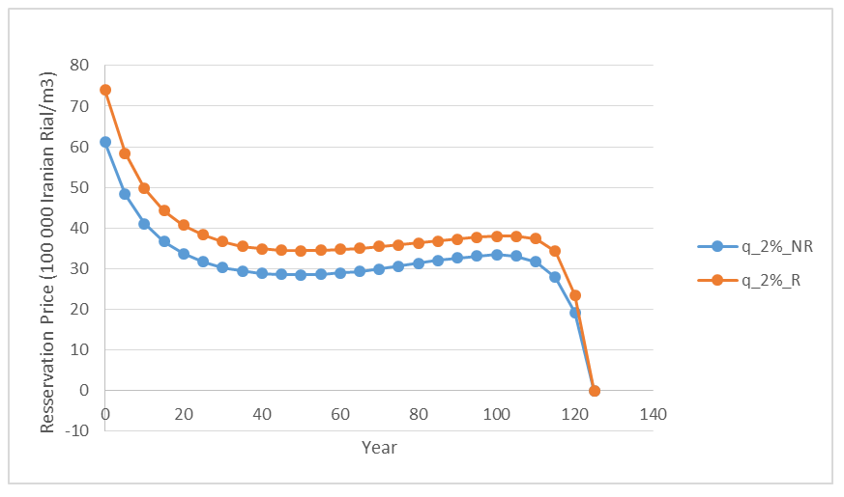

Figure 2: Optimal Reservation price as a function of time and risk level

Figure 3. shows the optimal reservation price as a function of diameter class for the real rate of interest 2%.

At time 0 we start with a tree in diameter class 40 cm. NR means ”No risk” and ”R” means that the real risk level of the Iranian market is considered.

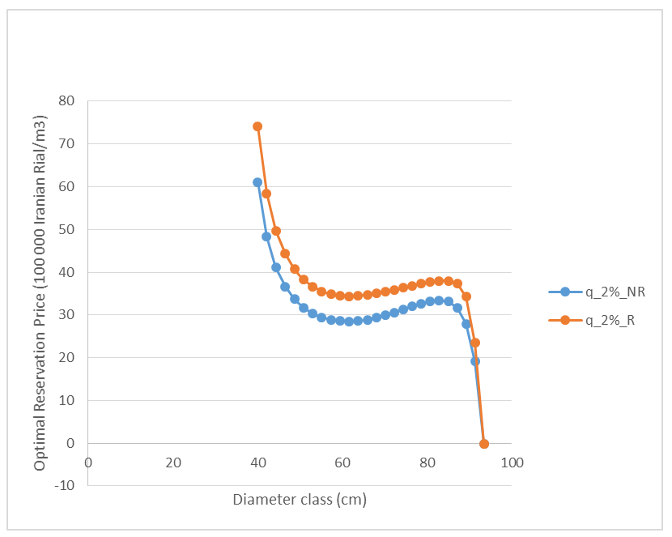

Figure 3: Optimal Reservation price as a function of diameter and risk level

Figure 4. shows the optimal expected present value as a function of diameter class for the real rate of interest 2%.

At time 0 we start with a tree in diameter class 40 cm. NR means ”No risk” and ”R” means that the real risk level of the Iranian market is considered.

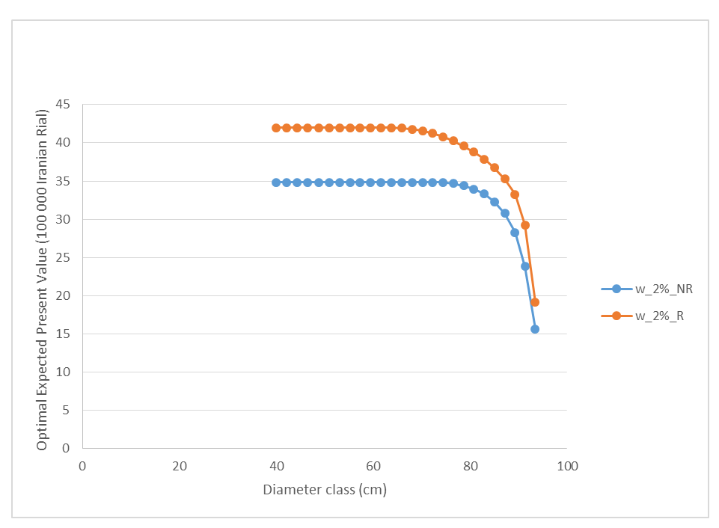

Figure 4: Optimal expected present value as a function of diameter and risk level

In Figure 5. We find the optimal harvest diameter probability distributions for the real rates of interest 2% and 3%.

At time 0 we start with a tree in diameter class 40 cm. The real risk level of the Iranian market is considered.

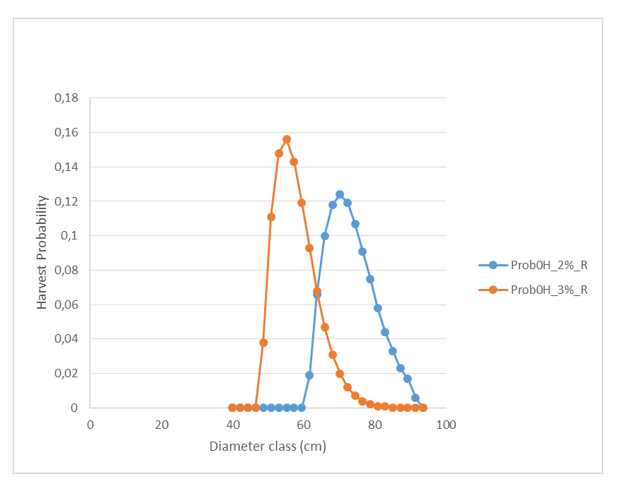

Figure 5: Optimal harvest diameter probability distribution as a function of rate of interest

# 4- Conclusions

A new basal area growth function and a new volume function have been derived for beech in the Iranian Caspian forest. Furthermore, the optimal reservation price function and the optimal expected present value function have been determined via stochastic dynamic programming for alternative levels of interest rate and risk. The optimal harvest year and optimal harvest diameter frequency distributions are determined for different degrees of risk and rate of interest.

### Acknowledgment

The authors are grateful to economic support from FORMAS.

### References

1. I. N. Vladimirov, and A. K. Chudnenko, “Multilevel Modeling of the Forest Resource Dynamics,” Math. Model. Nat. Phenom. Vol.4, pp. 72-88, 2009
2. S. Mohammadi Limaei, Economically optimal values and decisions in Iranian forest management. Doctoral thesis, Dept. of Forest Economics, SLU. Acta Universitatis agriculturae Sueciae, Vol. 2006:91. 2006.
3. E. E. Peters, Fractal Market Analysis, Applying Chaos theory to investment and economics. Wiley,1994
4. P. Lohmander, “Pulse extraction under risk and a numerical forestry application,,” Syst. Aanl. Model. Sim., vol. 5, pp. 339-354, 1988.
5. P. Lohmander, Pulse extraction under risk and a numerical forestry application. IIASA, International Institute for Applied Systems Analysis, Systems and Decisions Sciences, WP-87-49, 1987.
6. P. Lohmander, The economics of forest management under risk. Doctoral thesis , Dept. of Forest Economics, Swedish University of Agricultural Sciences, Report 79, 1987.
7. Shafaroud Forest Management Plan, General Office of Natural Resources in Guilan Province, Forest Management booklet, 2006.
8. P. Attarod, Investigation and statically analysis of forest growth in two ecological using multivariate southern and northern aspects using multivariate statically method, M.Sc thesis, Dept., of Forestry, University of Guilan, Iran, 1999.