Optimal adaptive stochastic control of large scale energy production under the influence of market risk

Peter Lohmandera*

a*Professor Dr., Optimal Solutions & Linnaeus University, Sweden

Abstract

The global energy market prices may be considered as stochastic processes. These prices may be strongly influenced (partly controlled) by large producers and cartels, since production levels influence the price level. Under such conditions, optimal dynamic production plans have to be optimized using adaptive controls, derived via stochastic control theory and/or stochastic dynamic programming. This paper presents alternative modelling options and a detailed analysis of a sample problem. It is possible to use stochastic dynamic programming as a master problem in combination with detailed multidimensional solutions to production and logistics problems for each state and stage. This can be done in finite time and also in infinite time, via stochastic dynamic programming in Markov chains with linear programming as a solution method. A sample problem is defined as a stochastic dynamic programming problem for optimal adaptive control of energy production under the influence of market risk and energy reserve constraints. General results concerning how the optimal adaptive production decisions and expected resource values are affected by increasing risk in the energy markets are reported. The main results are presented in connection to the present modelling results. General conclusions are presented and suggestions for future research are given.

Keywords: Optimal adaptive control; Stochastic dynamic programming; Market adapted oil production.

# 1- Introduction

We are interested in the optimal control of large scale energy production. We will focus on oil production, traded in the world market. The natural resources of the world, including energy resources, spatial distribution and properties, are well described by Ramade [17]. Presently, the world energy market is rapidly changing in several ways. The global warming concerns have increased the interest in renewable resources such as biomass and solar panels. The biomass potential is large, in particular in Russian Federation, and optimal plans considering harvesting and infrastructure investments have been developed. Lohmander [12] and [14] present these results. Lohmander [13] calculates an optimal dynamic path for Sweden and develops general guidelines for rational coordinated decisions [11]. The global energy market prices may be considered as stochastic processes. No analytical and/or statistical methods have yet made it possible to make good and reliable predictions of these prices several years in advance. In particular during the latest period, the oil price variations have been very rapid, highly unexpected and dramatic. These prices may be influenced (partly controlled) by large producers and cartels, since production levels influence the price level. Gao et al [1] study these things from an applied perspective and also estimate a function that shows how the production levels of the cartel OPEC can influence the world price level. Under highly stochastic market conditions, optimal dynamic production decisions have to be optimized using adaptive controls, derived via stochastic control theory and/or stochastic dynamic programming. In some cases, it may also be possible to determine optimal stochastic control functions with other methods. Wen et al [18] suggest the use of approximate dynamic programming in oil production optimization applications. Lohmander [8] shows how combinations of stochastic simulation and quasi gradient methods can be used in adaptive control of systems where the dimensionality is too high for the otherwise relevant method stochastic dynamic programming. Now, however, we will really apply stochastic dynamic programming.

* Corresponding author: *E-mail address*: Peter@Lohmander.com

One important reason for this choice of method is that the dominating question is how we should adapt oil production to the very large variations in the world market prices. In order to influence the prices, it is necessary to have considerable market power and to control large shares of the total world production. This can only be done with the help of coordinated production decisions, taken by a large cartel. For this reason, in this paper, we focus on optimal cartel decisions concerning the total market adapted production. With this definition of the problem, which according to the author of this paper is the most relevant when we are interested in the total profitability, the dimensionality is not very high. Hence, stochastic dynamic programming is a very well suited optimization tool that also, with probability one, gives globally optimal decisions. The application of stochastic dynamic programming does not make it impossible to handle many dimensions in large scale production and logistics systems in an optimal way. Lohmander [5] shows how large scale industrial production problems can be solved using a stochastic dynamic programming model as a master problem with a linear programming subroutine that for each stage and state in the master problem solves the state and stage relevant optimal production and logistics problems. The illustrating example comes from the forest industry but the approach can also be used in the energy sector. That application had a finite horizon. Lohmander [9] uses a related approach to solve large scale forest industry problems with stochastic prices of pulpwood and imported raw materials. In that analysis, infinite horizon is used in combination with Markov chain theory and linear programming as a tool to solve the master problem. So, in that case, linear programming is used at two levels: In the stationary infinite horizon stochastic dynamic programming master problem and in the solution of the local plan optimizations, for every possible state in the stochastic dynamic programming master problem. Methodologically related work can be found also in Lohmander [6] and [7] and the different methods are described in Lohmander [10].

# 2- Analysis

In every period until we reach the planning horizon, we maximize the expected present value,, for every possible level of the remaining reserve, , and for every market state, . takes the value 0 in period , which is shown in (1). In all earlier periods, the values of  are maximized for all possible reserve and market levels, via the control, the extraction level. In a period, before we reach, the control is selected so that the sum of the present value of instant extraction and the expected present value of future extraction is maximized. denotes the transition probability from market state to market state from one period to the next. The controlhas to belong to the set of feasible controls  which is a function of, and. Equations (1) and (2) summarize the principles and the recursive structure.

1. 
2. 

In the code segments shown in Figures 1 and 2, an introductory sample problem is numerically defined and solved. hopt(t,s,m) denotes the optimal values of the control. d(t) is the period dependent discounting factor, based on the assumed rate of interest 5% in continuous time. In Figure 1, the three dimensional code loop makes sure that all values of f(.) and hopt(.) are initially set to zero.

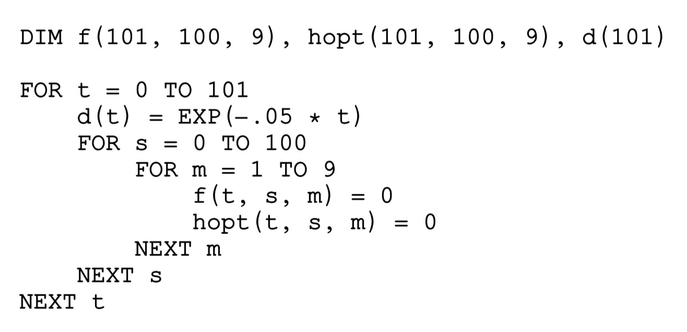

Figure 1: Dimensions and initial conditions

Figure 2 shows how the stochastic dynamic programming problem is solved, based on the following special assumptions:

(3) 

The extraction level is only constrained by the remaining reserve level. Extraction capacity constraints can, if needed, easily be included in the problem specification shown in Figure 2. The market state probabilities are calculated from a stationary and discrete approximation of a uniform probability density function with autocorrelation zero.

(4) .

is the profit discounted to year zero and is a strictly concave and quadratic function of . The “net price”, , price minus variable costs per unit, is given in (5). Fix costs do not affect the optimal solutions and are not included in the model.

(5) 

This means that the net price is negatively affected by the production level. When the market state is 5, the “normal market state”, the net price function is . If the market state is higher or lower, the net price functions moves up or down.

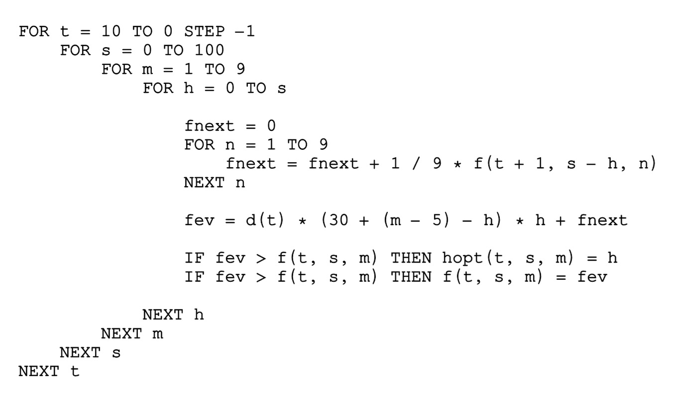

Figure 2: Stochastic dynamic programming via backward recursion and the sample problem

## 3- Results

The results found in Tables 1, 2, 3 and 4 are based on the numerical specifications found in Figures 1 and 2.

Table 1 shows the optimal market and reserve level dependent extraction levels hopt(.) in period 0. We find that the optimal extraction level is an increasing function of the market state and of the size of the remaining reserve.

Table 1 – Optimal extraction table for t = 0.

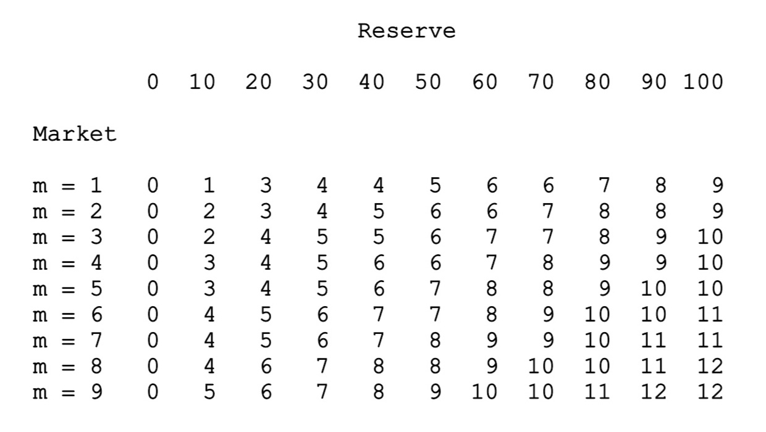

Table 2 includes the optimal objective function values, the expected present values, f(.), in period 0. The optimal expected present value is an increasing function of the market state and of the size of the remaining reserve.

Table 2 – Optimal expected present value table for t = 0.

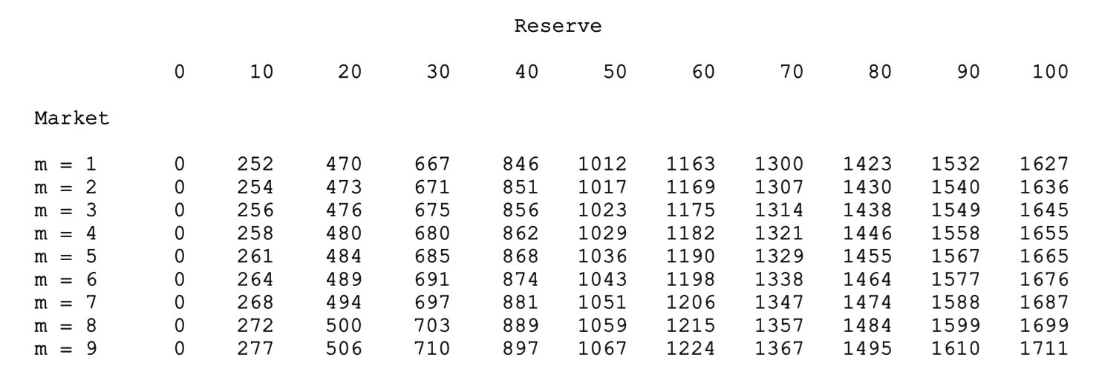

Table 3 contains similar information as Table 1. However, in Table 3, we have reached period 5. The general tendencies are the same in period 0 and period 5, but in period 5 we should extract more of the resource than in

period 0, in case the market state and the reserve level are the same. This is understandable, since in period 5, the number of remaining periods is lower. Hence, the probability that we will be able to sell the resource at a much higher price in the future is reduced. Furthermore, if we plan to strongly increase extraction in the near future, this will reduce the price level very much. For these reasons, it is better to extract more of the resource in period 5, even if the prices are not very good and even if we have not a very large remaining resource.

Table 3 – Optimal extraction table for t = 5.

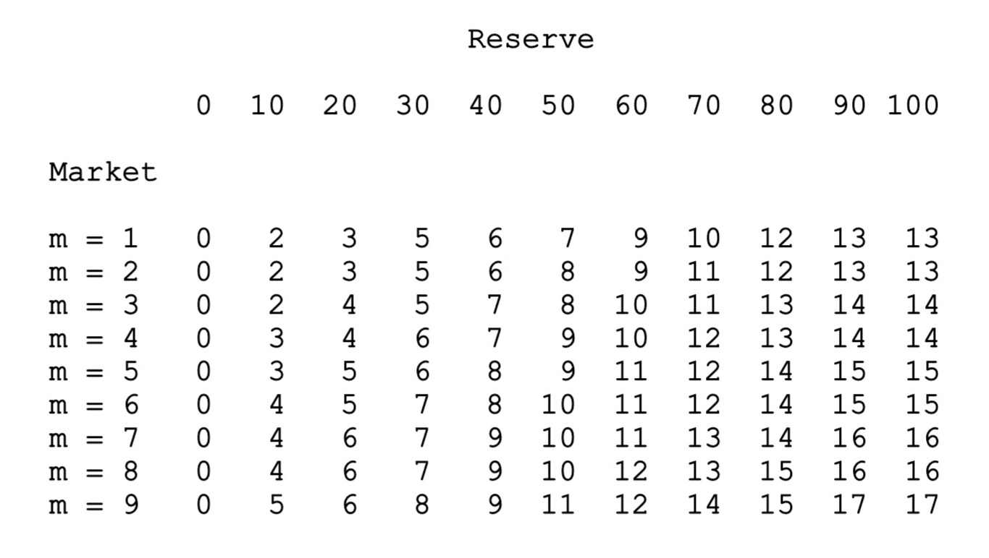

Table 4 corresponds to Table 2, but we have now reached period 5. The optimal expected present values are still increasing functions of the market state and the size of the remaining reserve, but all values are lower than the corresponding values in period 0. There are several reasons for this: Discounting during five years reduces all profits. Furthermore, since a lower number of periods remain, the number of options to extract during very good market states has decreased. Finally, the remaining reserve has to be distributed over a lower number of periods, which gives more negative effects on the price level.

Table 4 – Optimal expected present value table for t = 5.

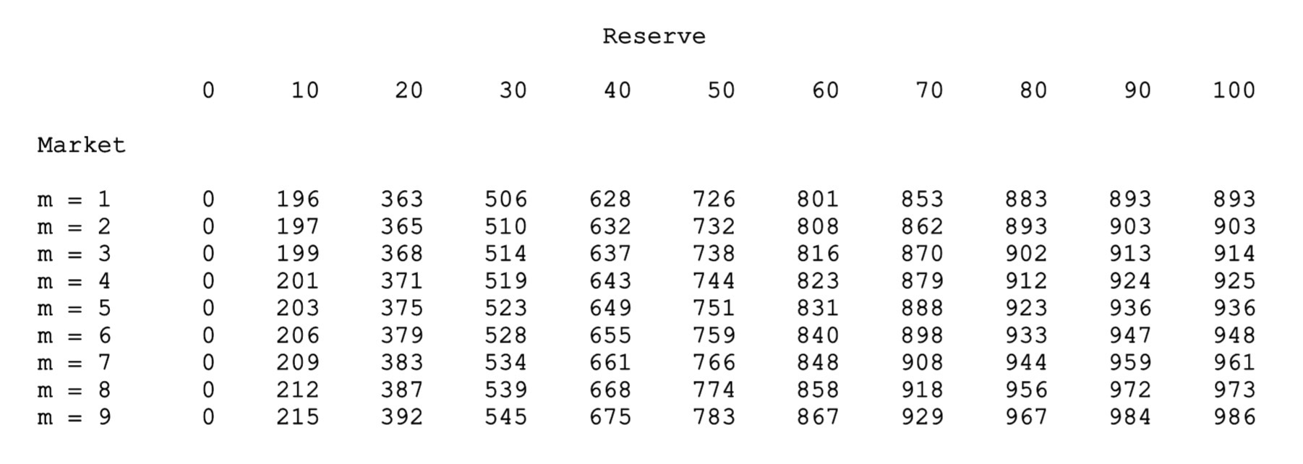

In the numerical sample problem presented and analysed in this paper, the profit function is a quadratic and concave function of the control, the extraction level. Hence, the marginal profit function is a linear function of the extraction level. In such cases, increasing risk in the future market prices usually do not influence the optimal present extraction levels in problems of this nature, as long as the optimal production level is always strictly positive. If the marginal profit function is strictly concave, however, the optimal present extraction level is a strictly increasing function of the future risk level. If the marginal profit function is strictly convex, the optimal present extraction level is a strictly decreasing function of the future risk level. If the marginal profit function is strictly concave, the optimal expected present value is a strictly decreasing function of the future risk level. If the marginal profit function is strictly convex, the optimal expected present value is a strictly increasing function of the future risk level. These results have been proved and shown by Lohmander [2] and [4], via comparative statics analysis in stochastic dynamic programming. A more detailed version of this type of analysis is found in [3]. Lohmander [15] and [16] contain similar proofs based on an alternative method.

# 4- Conclusion

Stochastic dynamic programming is a fantastic method that can be used in many highly relevant problems, in particular with stochastic market prices and adaptive production decisions. A common opinion is however that the “curse of dimensionality” makes it impossible to handle relevant real world problems with this method. For this reason, several attempts have been made to develop alternative approaches. In the light of this situation, the author suggests the use of stochastic dynamic programming as a master problem combined with linear programming solutions to optimal decisions at each stage and state. This makes it possible to keep the real stochastic structure of the problem and to optimize the relevant adaptive production level decisions. At the same time, any level of detail can be handled in the many production and logistics oriented decisions at lower levels. These approaches are found here: Lohmander [5] and [9]. Observe that linear programming can be replaced by quadratic programming as local solution provider in the different states and stages. Then, globally optimal solutions to large scale problems with quadratic objective functions can be derived in a finite number of iterations.

### References

1. Gao W., Hartley P.R., Sickles, R.C., Optimal dynamic production from a large oil field in Saudi Arabia, Empirical Economics, September 2009, Volume 37, Issue 1, pp 153-184, http://link.springer.com/article/10.1007%2Fs00181-008-0227-9
2. Lohmander, P., Continuous extraction under risk, IIASA, International Institute for Applied Systems Analysis, Systems and Decisions Sciences, WP-86-16, March 1986, <http://www.iiasa.ac.at/Admin/PUB/Documents/WP-86-016.pdf>, <http://www.lohmander.com/WP-86-016.pdf>
3. Lohmander, The economics of forest management under risk, Swedish University of Agricultural Sciences, Dept. of Forest Economics, Report 79, 1987 (Doctoral dissertation), 311p
4. Lohmander, P., Continuous extraction under risk, SYSTEMS ANALYSIS - MODELLING - SIMULATION, Vol. 5, No. 2, 131-151, 1988, <http://www.Lohmander.com/PL_SAMS_5_2_1988.pdf>
5. Lohmander, P., Stochastic dynamic programming with a linear programming subroutine: Application to adaptive planning and coordination in the forest industry enterprise, in Lohmander P. (editor), SCANDINAVIAN FOREST ECONOMICS, No. 31, 51p, 1989, http://www.Lohmander.com/Lohmander_STPLP_1990.pdf
6. Lohmander, P., A quantitative adaptive optimization model for resource harvesting in a stochastic environment, SYSTEMS ANALYSIS - MODELLING - SIMULATION, Vol. 7, No. 1, 29-49, 1990, <http://www.Lohmander.com/PL_SAMS_7_1_1990.pdf>
7. Lohmander, P., The optimal dynamic production and stock levels under the influence of stochastic demand and production cost functions: Theory and application to the pulp industry enterprise, SYSTEMS ANALYSIS - MODELLING - SIMULATION, Vol.10, Issue 2, 1992, http://www.Lohmander.com/Lohmander_SAMS_10_1992.pdf
8. Lohmander, P., Decision optimization with stochastic simulation subroutines: Relation to analytical optimization of capacity investment and production, presented at the "4'th International Conference of Systems Analysis and Simulation 1992", SYSTEMS ANALYSIS - MODELLING - SIMULATION, Vol. 10, 279-314, 1993, <http://www.Lohmander.com/PL_SAMS_10_1993.pdf>
9. Lohmander, P., Stochastic Dynamic Optimization of Forest Industry Company Management, INFORMS International Meeting 2007, Puerto Rico, Power Point Presentation, http://www.Lohmander.com/SDO.ppt
10. Lohmander, P., Adaptive Optimization of Forest Management in a Stochastic World, in Weintraub A. et al (Editors), Handbook of Operations Research in Natural Resources, Springer, Springer Science, International Series in Operations Research and Management Science, New York, USA, pp 525-544, 2007
11. Lohmander, P., Guidelines for Economically Rational and Coordinated Dynamic Development of the Forest and Bio Energy Sectors with CO2 constraints, Proceedings from the 16th European Biomass Conference and Exhibition, Valencia, Spain, 02-06 June, 2008 (In the version in the link, below, an earlier misprint has been corrected. ) <http://www.Lohmander.com/Valencia2008.pdf>
12. Lohmander, P., Methodology for optimization of coordinated forestry, bioenergy and infrastructure investments with focus on Russian Federation, Plenary Report and Abstract, Forests of Eurasia, Publishing House of Moscow State Forest University, September 19 - 25, 2010, <http://www.lohmander.com/Moscow10/Moscow10_PL.pdf>, <http://www.lohmander.com/Moscow_2010/Lohmander_Moscow_2010.ppt>
13. Lohmander, P., Optimization of the forest and bioenergy supply chain in Sweden, SSAFR-2011, 14th Symposium for Systems Analysis in Forestry, Maitencillo, Chile, March 8-11, 2011, <http://www.lohmander.com/Chile_2011/Chile_2011_Chain_Lohmander.ppt>
14. Lohmander, P., Methodology for optimization of coordinated forestry, bioenergy and infrastructure investments with focus on Russian Federation, Moscow State Forestry University Forest Bulletin, ISSN 1727-3749, No 84, Issue 1, 2012, <http://www.lohmander.com/PLMosc12.pdf>
15. Lohmander, P., Optimal present resource extraction under the influence of future risk, The 8th International Conference of Iranian Operations Research Society, Department of Mathematics, Ferdowsi University of Mashhad, Mashhad, Iran, 21-22 May 2015, <http://www.Lohmander.com/PL_IRAN_A_ABS_2015.pdf>, <http://www.Lohmander.com/PL_IRAN_A_2015.pptx>
16. Lohmander, P., Optimal continuous natural resource extraction with increasing risk in prices and stock dynamics, WCBE 2015, BIT's 5th Annual World Congress of Bioenergy 2015, Xi'an, China, September 24-26, 2015, <http://www.Lohmander.com/PL_WCBE_2015.pptx>
17. Ramade, F., Ecology of natural resources, John Wiley & Sons Ltd, 1984
18. Wen Z., Durlofsky L.J., Van Roy B., Aziz K., Use of approximate dynamic programming for production optimization, The 2011 SPE Reservoir Simulation Symposium held in Woodlands, Texas, U.S.A., 21-23 February 2011, Stanford University, Stanford, California, 94305 USA, http://web.stanford.edu/~bvr/pubs/reservoirADP.pdf