Optimal stochastic control in continuous time with Wiener processes:

- General results and applications to optimal wildlife management

**Peter Lohmander 1,\***

*1 Linnaeus University and Optimal Solutions, Sweden*

*\* Professor Dr. Email: Peter@Lohmander.com*

## Abstract

This paper presents a stochastic optimal control approach to wildlife management. The objective value is the present value of hunting and meat, reduced by the present value of the costs of plant damages and traffic accidents caused by the wildlife population. First, general optimal control functions and value functions are derived. Then, numerically specified optimal control functions and value functions of relevance to moose management in Sweden are calculated and presented.

**Keywords**: Stochastic optimal control, Wildlife management, Hamilton-Jacobi-Bellman equation, Partial differential equations, Moose, Optimization

**1.Introduction**

This paper starts with a briefing on problem relevant parts of general stochastic optimal control theory, continues with the derivation of general function solutions to the optimal wildlife management problem, and ends with specific derivations and results of relevance to optimal moose management in Sweden.

**2. The General Stochastic Optimal Control Problem**

The general optimal stochastic control methodology in continuous time is briefly presented here. Related introductions with more details are found in Sethi and Thompson [1], Malliaris and Brock [2] and Winston [3]. Lohmander [4] presents connected methods in discrete time. We want to maximize the objective function. is the state variable, is the closed loop control variable and is a standard Wiener process.

. According to the Bellman principle of optimality, we may determine the value function  as the maximum of the sum of the net reward during the first short time interval,, and the value function directly after that time interval.

. A Taylor function approximation gives:



In the Taylor function, we need: 

and . Stochastic calculus tells us: .

Hence, we get:  and . Furthermore, . As a result, we get:

. Hence, the value function is approximately:

. 

Let . . Since is not a function of u, we obtain the *”Hamilton-Jacobi-Bellman equation”:*

 with boundary condition: .

**3. The particular stochastic optimization problem**

We want to maximize the expected present value of wildlife management. is the control variable, the level of hunting at time t.  is the size of the wildlife population.  are objective function parameters. The net revenue of the hunting and meat values, , is a strictly concave function of the hunting level. , which is proportional to the population level, , is the cost of destroyed forest plantations and cost of traffic accidents caused by the wildlife population. The population growth increases with the size of the population and decreases with the hunting level. The magnitudes of the stochastic population changes depend on the standard Wiener process, , the size of the population, and the risk parameter . is the rate of interest in the capital market.



The net profit at a particular point in time is: . The *”Hamilton-Jacobi-Bellman equation” becomes:*



Now, the problem is to determine the value function and the control function that satisfy the Hamilton-Jacobi-Bellman (= HBE) equation. Let us assume that the value function can be expressed this way: . . Then, these partial derivatives can be calculated:







As a result, we can rewrite the HBE:





We have to optimize the control, .



The first order optimum condition and the second order maximum condition are:

 

The derived value of is a unique maximum, . ,





Using the optimal values of the control, via the optimized control function, we get:

. The HBE is:

















Now, we have obtained a quadratic function, that always has to be zero. If the function is not zero, then the HBE equation is violated. Since the function must hold for all possible values of , the size of the population, it is clear that we have three equations that can be used to determine the parameters .











Now, we can use the newly derived function for in the expression for .













Now, the expression for can be used in the expression for .



Now, we know the parameters of the value function. They are explicit functions of the parameters in the initially specified optimization problem.





Now, we will do the same for the optimal control function. What are the control function parameters?



First, we introduce the functions of and  in the expression for :



**4. The numerically specified case**

Let us enter the particular numerical parameters of a real problem. Lohmander [5] estimated revenue and cost functions and calculated the optimal equilibrium moose population in Sweden, under deterministic assumptions and no discounting. The size of the moose population is however not perfectly predictable and the capital market often, but not always, includes strictly positive interest rates. Random disturbances can have large effects. We may determine the optimal stochastic control of the moose population in Sweden, based on the new general functions that have been derived in this paper. The figures and functions presented in Lohmander [5] and [6] can be used to derive the parameters of the stochastic control problem. Please note that the quadratic objective function in the stochastic optimal control problem of this paper is an approximation of the particular objective function presented in [5] and [6]. Both functions are strictly concave. The quadratic approximation fits the original function very well within the selected approximation region. Of course, the derived general equations can be used also for other animals and in other countries of the world. These parameter values were estimated: g = 1/3, k = 600, p = 90, f = 90. Let r = 1/30. In Figure 1. and Figure 2., we can inspect the optimal value function and the optimal control function.

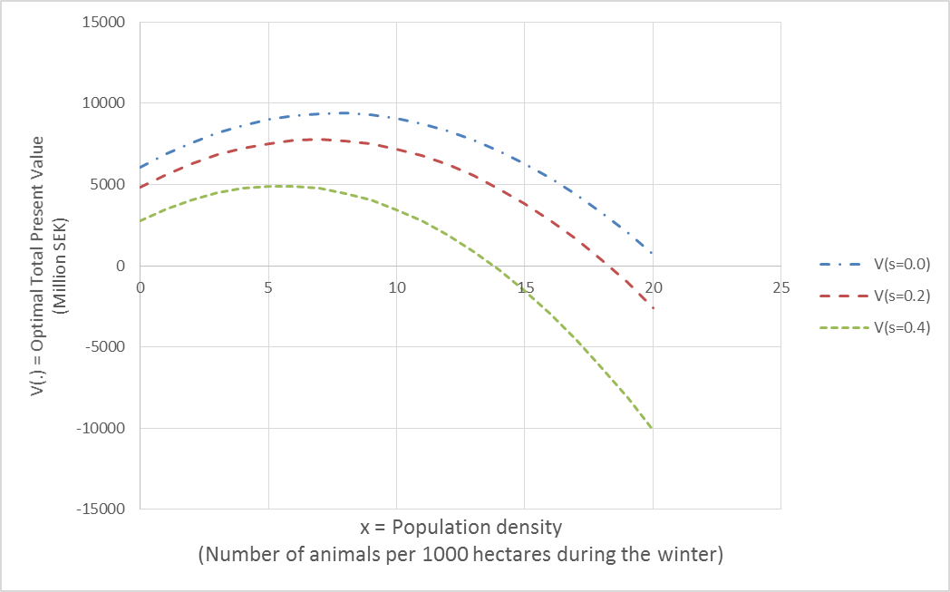

Figure 1. The optimal total present value function, V(.) as a function of the population density, x, and the stochastic parameter s.

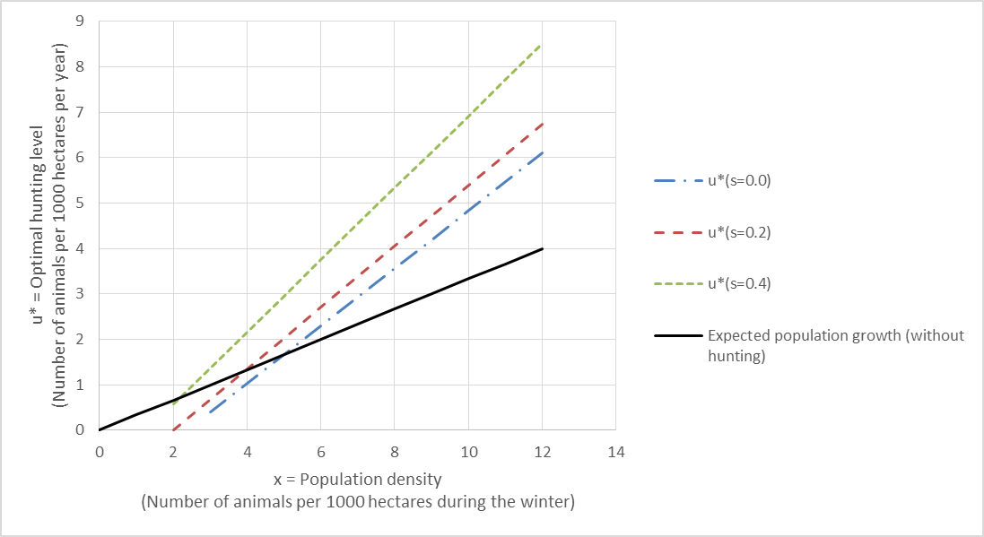

Figure 2. The optimal control, the hunting level, u*, as a function of the population density, x, and the stochastic parameter s.

Figure 1. shows that the optimal value function is a strictly concave function of the size of the population. The value is a decreasing function of the stochastic parameter s. The optimal population density, with respect to the value function, is a decreasing function of s. Note that the optimal population density, with respect to the value function, is not equal to the optimal population density in the long run. The value may be high with a rather high (initial) population, since the control (= hunting level) initially can be high, gradually reducing the population to a much lower level. Figure 2. shows the optimal control, the hunting level, as a function of the size of the population. Note that the optimal control level is an increasing function of the stochastic parameter s. The intersections of the alternative control functions and the line representing “expected population growth without hunting”, show the population levels and the hunting levels where the expected values of the instant population changes are zero. Observe that, if s increases, these “expected equilibria” intersections obtain lower population densities and lower hunting levels. Since the first derivatives of the alternative control functions with respect toare higher than the first derivative of “the expected population growth without hunting”, with respect to , the ”expected equilibria” are dynamically stable.

**5. Conclusions**

This paper has derived and presented a stochastic optimal control approach to wildlife management. The objective value is the net present value of hunting and meat, reduced by the present value of the costs of plant damages and traffic accidents caused by the wildlife population. General optimal control functions and value functions were derived. Then, numerically specified optimal control functions and value functions of relevance to moose management in Sweden have been calculated and presented.

**6. Acknowledgments**

The author appreciates travel grants from FORMAS.

**7. References**

[1] S.P.Sethi and G.L.Thompson, Optimal Control Theory, Applications to Management Science and Economics, Kluwer Academic Publishers, Boston, (2000).

[2] A.G.Malliaris and W.A.Brock, Stochastic Methods in Economics and Finance, North-Holland, Amsterdam, (1984).

[3] W.L.Winston, Operations Research: Volume Two, Introduction to Probability Models, Thomson Brooks/Cole, 4 ed., (2004).

[4] P. Lohmander, Adaptive Optimization of Forest Management in a Stochastic World, in Weintraub A. et al (Editors), Handbook of Operations Research in Natural Resources, Springer, Springer Science, International Series in Operations Research and Management Science, New York, USA, (2007) 525-544.

[5] P. Lohmander, Hur många älgar har vi råd med?, Vi Skogsägare, Debatt, Nr 1, (2011).

[6] P.Lohmander,Älgens ekonomi och den ekonomiskt optimala älgstammen, Skogen och Viltet, SLU, Umea, November 24, (2011). <http://www.lohmander.com/LohmanderSkogenochViltet2011.ppt> ,  
<http://www.lohmander.com/LohmanderSkogenochViltet2011.pdf>