Methodology for optimization of coordinated forestry, bioenergy and infrastructure
investments with focus on Russian Federation

Professor Peter Lohmander
Department of Forest Economics,
Faculty of Forest Science,
Swedish University of Agricultural Sciences (SLU),
SE – 901 83 Umea, Sweden
e-mail #1: peter@lohmander.com
e-mail #2: plohmander@hotmail.com

Russian Federation has a very large sustainable forest harvesting potential

In large regions of the world, such as Russian Federation and Canada, the potential future sustainable forest harvesting levels are several times higher than present harvesting. At an international forest sector symposium in Russia, March 2009, Lohmander showed that all kinds of forest raw material dependent activities in Russian Federation can be very strongly increased [1]. “International regional” studies followed [2], an international research agenda with partners from most parts of the world was developed [3], [4], an analysis of Canada [5] and a presentation for Chile [6] were developed.

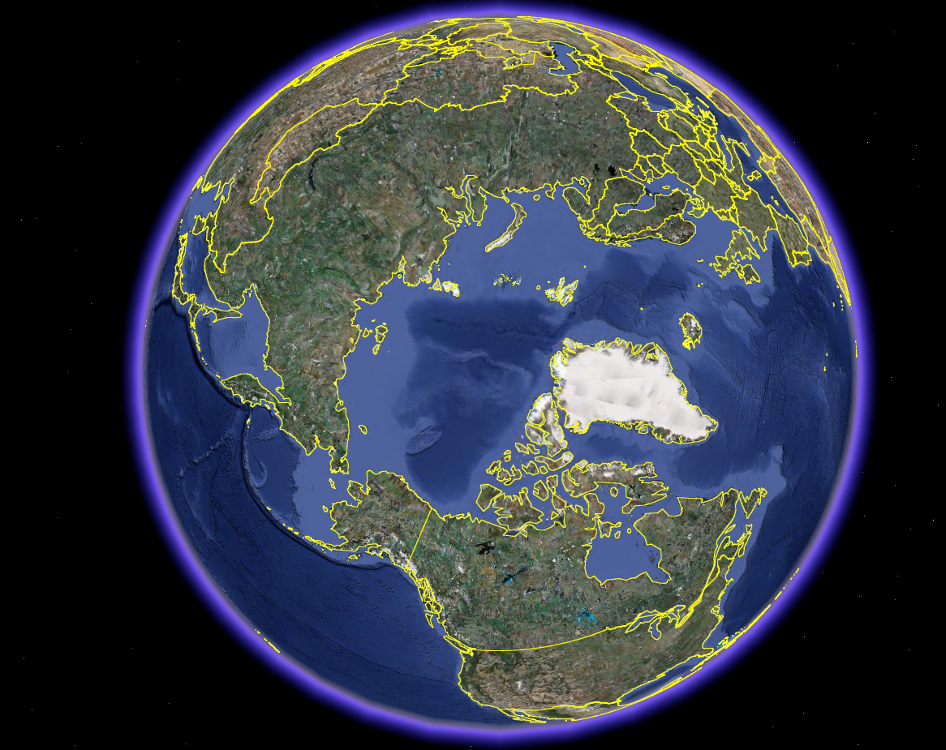

Figure 1.
Russian Federation has the largest forest in the world and the harvest can be very strongly increased in a sustainable way. Sources: Lohmander [1, 2, 8, 10].

Analysis of the forest sector of Russian Federation and an important opportunity to cooperate with European Union

In Russian Federation, the utilization of the forest resources can be very strongly increased in a sustainable way. It is possible to increase the industrial utilization of raw materials from the forests, such as stem wood and other assortments, irrespective of how these assortments are distributed between saw mills, pulp mills and companies in the energy industry.

Figure 2.
The ratios between harvest levels and stock levels in different regions.
Sources: FAO and Lohmander [10].

The complex problems of the global system with green house gases and global warming and the level of the carbon stock in the forests, has become a dominating topic in all media and conferences during the latest years. With increasing utilization of the production potential of the forests, the forests can capture more CO2 from the atmosphere and we may solve the global warming problem. When we harvest a forest and use the timber to build wooden houses, bridges and other constructions, the carbon that was originally captured by and stored in the forest is moved to the constructions. When we harvest the forest, the forest land is released and can be used for a new plantation. This new plantation can absorb even more CO2 from the atmosphere. In case we do not use the old forest and harvest it, the forest net growth sooner or later stops. Then, the forest does not contribute to the net uptake of CO2 anymore.

For these reasons, European Union, EU, has defined a target for renewable energy. It says that EU should have at least 20% renewable energy in the year 2020. In the year 2007, the gross inland energy consumption of EU was 1806 Mtoe or 21000 TWh. The renewable energy represented 7.8%. Hence, EU needs 2563 TWh more of renewable energy, each year, in order to meet the 20% target of the year 2020. This amount of renewable energy can for instance be found in approximately 1300 million cubic metres of wood. All the background figures, references and derivations are found in Lohmander [10]. Russian Federation and EU now have the opportunity to cooperate. Both parties would benefit very much from such cooperation. If we use a part of the forest resources of Russian Federation for this purpose, exporting energy wood to EU, we can meet the 20% renewable energy target in EU and at the same time generate a considerable economic profit in Russian Federation.

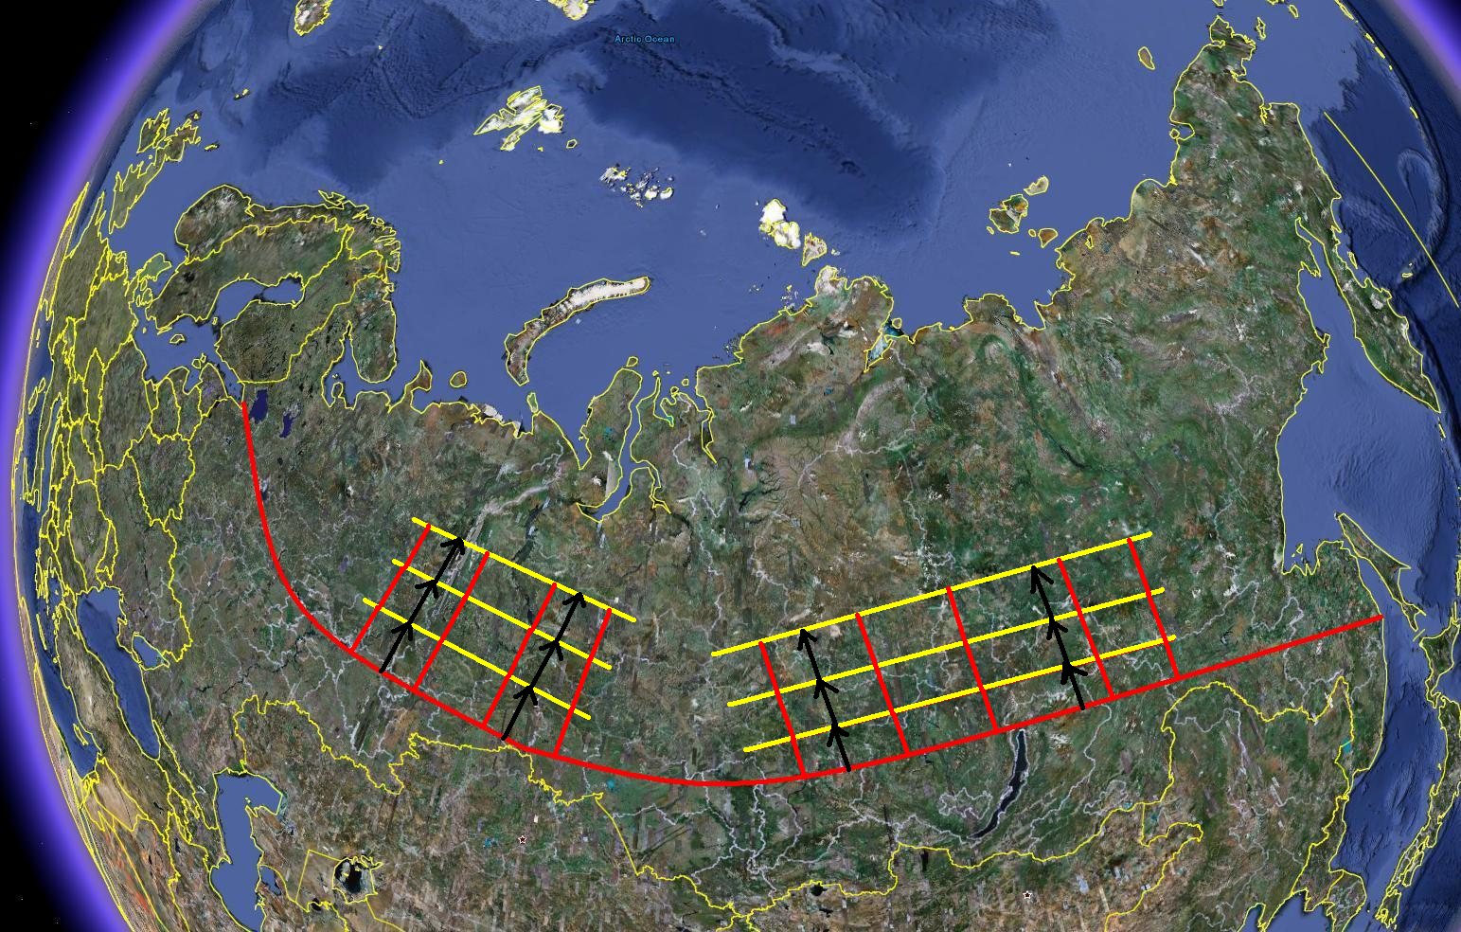

Figure 3.
Sequential expansion of infrastructure such as railroads and roads. Investments in infrastructure and forest sector activities, such as harvesting and plantation, should be optimized in combination. Lohmander [1, 10].

The general structure of the optimization problem of coordinated expansion of sustainable forest and bio energy supply chains, infrastructure and industrial plants has been studied. Alternative dynamic optimization models have been defined. Optimal solutions have been derived for alternative cases and conclusions have been made. Capacities of industries of different kinds, using raw materials from the forests, should be strongly expanded. This also leads to increased employment in all concerned regions over an infinite horizon.

Figure 4.
Structure of the objective function of one of the forestry and infrastructure investment optimization models in Lohmander [10].

Figure 5.
The optimal advancement, expansion of infrastructure and forestry, from south to north, in Siberia, over time, in one of the cases studied in Lohmander [10].

Figure 6
The optimal harvest volume in a central part of Siberia, over time, in one of the cases studied in Lohmander [10].

Figure 7.
The renewable energy from a part of Siberia, over time, in one of the cases studied in Lohmander [10].

Conclusions

In Russian Federation, the potential sustainable forest harvesting level is more than ten times higher than present harvesting. A part of the forest resource may be used as a sustainable source of energy in EU, where the target is 20% renewable energy in the year 2020. The plan, briefly presented in this paper, makes sure that Europe will get the desired amount of renewable energy. At the same time, the EU climate targets can be met and considerable profits are generated in Russian Federation. According to one optimized case presented in Lohmander [10], it should be possible to generate profits with a present value of approximately 200 billion EURO. Of course, with more detailed numerical background information, it would be possible to derive a more exact profitability estimate. Now, the next important step is to make sure that concrete negotiations between the involved parties are initiated and that the real solution comes true.

References

[1] Lohmander, P., Strategic options for the forest sector in Russia with focus on economic optimization, energy and sustainability, (Full paper in English with short translation to Russian), ICFFI News, Vol. 1, Number 10, March 2009, http://www.Lohmander.com/RuMa09/RuMa09.htm
International seminar, ECONOMICS OF FORESTRY AND FOREST SECTOR:
ACTUAL PROBLEMS AND TRENDS, St Petersburg, Russia, March 2009, http://www.lohmander.com/RuMa09/ProgramRuMa09.pdf

[2] Lohmander, P., Strategiska möjligheter för skogssektorn i Ryssland,
Nordisk Papper och Massa, Nr 2, 2009, http://www.Lohmander.com/PL_NPM_2_2009.pdf
http://www.Lohmander.com/PL_RuSwe_09.pdf , http://www.Lohmander.com/PL_RuSwe_09.doc

[3] Lohmander, P., Rational and sustainable international policy for the forest sector - with consideration of energy, global warming, risk, and regional development, 2009-08-05, http://www.lohmander.com/ip090805.pdf

[4] Lohmander, P., Strategiska möjligheter för skogssektorn i Ryssland, SkogsSverige 2009-08-10, http://www.skogssverige.se/nyheter/nyhetsdokument/PL_NPM_2_2009.pdf
[5] Lohmander, P., Strategic options for the forest sector in Canada with focus on economic optimization, energy and sustainability - Motives for integration in a global project, Presentation at the Canadian Embassy in Stockholm, Sweden, Monday 2009-08-17, http://www.lohmander.com/CanEmbPL090817.ppt , http://www.lohmander.com/CanEmbPL090817.pdf

[6] Lohmander, P., Rational and sustainable international policy for the forest sector with consideration of energy, global warming, risk and regional development, Chilean Embassy (Vinnova) in Stockholm, 2009-10-07, http://www.lohmander.com/IntPres091007.ppt

[7] Lohmander, P., Derivation of the Economically Optimal Joint Strategy for Development of the Bioenergy and Forest Products Industries, European Biomass and Bioenergy Forum, MarcusEvans, London, UK, 8-9 June, 2009, http://www.lohmander.com/London09/London_Lohmander_09.ppt &
http://www.lohmander.com/London09.pdf

[8] Lohmander, P., Optimum Combination of Biomass Production with Investments in Infrastructure, Abstracts, European Biomass and Bioenergy Forum, September 13-15, 2010
http://www.lohmander.com/EBBF_2010_Lohmander.ppt
http://www.lohmander.com/EBB_2010.pdf

[9] Lohmander, P., Zazykina, L., Rational and sustainable utilization of forest resources with consideration of recreation and tourism, bioenergy, the global warming problem, paper pulp and timber production: A mathematical approach, Proceedings of the II international workshop on Ecological tourism, Trends and perspectives on development in the global world, Saint Petersburg Forest Technical Academy, April 15-16, 2010
http://www.Lohmander.com/SPb201004/Lohmander_Zazykina_SPbFTA_2010.pdf
http://www.Lohmander.com/SPb201004/Lohmander_Zazykina_SPbFTA_2010.doc
http://www.Lohmander.com/SPb201004/PPT_Lohmander_Zazykina_SPbFTA_2010.ppt
http://www.Lohmander.com/SPb201004/PPT_Lohmander_Zazykina_SPbFTA_2010.pdf
[10] Lohmander, P., “Methodology for optimization of coordinated forestry, bioenergy and infrastructure investments with focus on Russian Federation”, Forests of Eurasia, Moscow, 2010, Complete power point presentation with all derivations and graphs:
http://www.lohmander.com/Moscow_2010/Lohmander_Moscow_2010.ppt

Preliminary version of summary in Russian:

Please observe: The Russian text found below was written based on a much earlier version of the English text. For this reason, it is important that a new translation to Russian is made, based on the English version found in this document.

Методология оптимизации координированных инвестиции в лесное хозяйство,
биоэнергетику и инфраструктуры на примере РФ.

Профессор Петер Ломандер
Шведский университет сельского хозяйства (SLU), 90183 Умео, Швеция
Электронная почта: peter.lohmander@sekon.slu.se

Имеются хорошее перспективы значительного увеличения объемов лесосырья разного
ассортимента, например круглого леса. Независимо от распределения между
лесопилками, ЦБК и энергетическими компаниями. Изучаются общие пути оптимизации скоординированного расширения мощностей поставщиков лесосырья и биоэнергии и инфроструктуры. Рассматриваются альтернативные динамические модели. Выводятся оптимальные решения для различных случаев и делаются предварительные выводы по поводу значительного расширения промышленных мощностей разного рода использующих лесосырье, что в свою очередь, ведет к увеличению занятости во всех заинтересованных лесных регионах в рассматриваемом временном периоде планирования. Общая экономическая стоимость, текущая дисконтированная стоимость всех операций в лесном хозяйстве, затраты на производство лесопродуктов и энергии значительно увеличиваются если вырубка и расширение объемов сырья производятся в рамках предлагаемых оптимизационных моделей. Кроме того за последние годы, доминирующей темой во всех СМИ и на конференциях стали комплексные проблемы связанные с: глобальным потеплением, парниковым эффектом и уровнем запаса углерода в лесах. При оптимизации использования промышленных лесов, леса способны удерживать больше СО2 и таким образом мы можем решить проблему глобального потепления. Когда мы вырубаем лес и используем пиломатериалы, для постройки деревянных домов, мостов и других конструкций, накопленный в древесине углерод остается в конструкциях.
Более того, при вырубке освобождается место под новые плантации, которая в свою
очередь, может абсорбировать больше углерода из атмосферы. Если мы не будем
использовать неприрывное неистощительное лесопользование, то рано или поздно чистый рост леса прекращается, что ведет к прекращению поглощения СО2 из атмосферы.

