Methodology for optimization of continuous cover forestry with consideration of recreation and the forest and energy industries

Professor Peter Lohmander
Department of Forest Economics,
Faculty of Forest Science,
Swedish University of Agricultural Sciences (SLU),
SE – 901 83 Umea, Sweden
e-mail #1: peter@lohmander.com
e-mail #2: plohmander@hotmail.com

PhD Student Zazykina L.

Introduction

Forests can be, and are, used for many different purposes. It is important to consider these simultaneously. In several regions, in particular close to large cities, such as Paris and Moscow, the economic importance of recreation forestry is very high in relation to the economic results obtained from traditional “production oriented” forest management. This does however not imply that production of timber, pulpwood and energy assortments can not be combined with rational recreation forestry. Considerable harvesting is often necessary in order to obtain a forest density that is optimal when we also consider recreation.

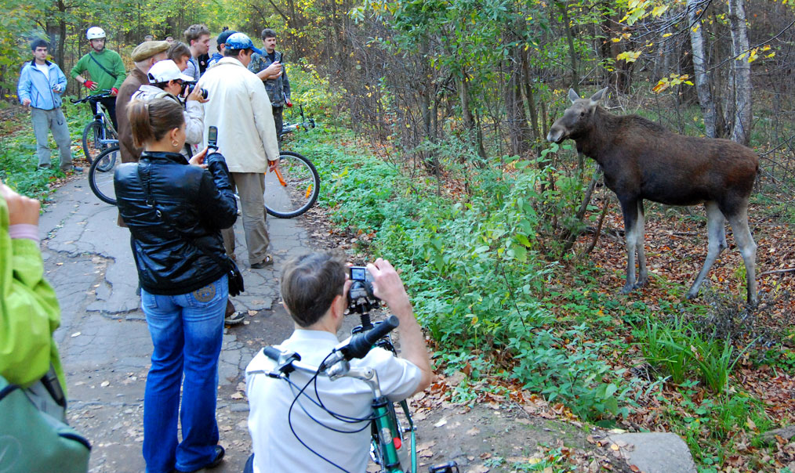

Figure 1.
Recreation activities in a forest close to Moscow, September 2010. A large number of people can simultaneously study moose, ride bicycle, collect mushrooms and hike. The total recreation value per hectare is very high, in relation to the value of the production of timber in the same area, partly because the population density is very high in the Moscow region. Photo: Peter Lohmander, September, 2010.

A new methodological approach to optimization of forest management with consideration of recreation and the forest and energy industries has been developed. It maximizes the total present value of continuous cover forest management and takes all relevant costs and revenues into account, including set up costs. The optimization model includes one section where the utility of recreation, which may be transformed to the present value of net revenues from recreation, is added to the traditional objective function of the present value of the production of timber, pulpwood and energy assortments.

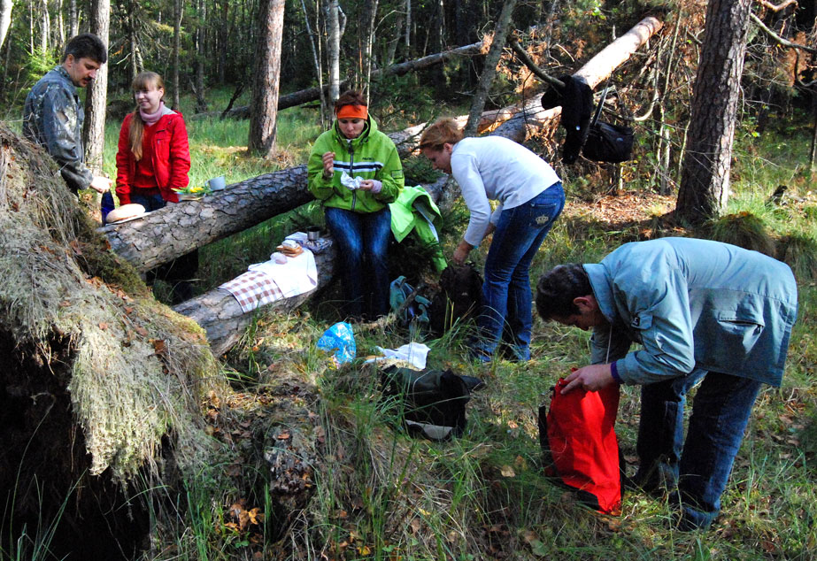

Figure 2.
The picture shows a typical recreation site in a part of a forest close to Moscow. It is important to observe that the selected recreation site has a forest density that is much lower than in most other parts of the forests. In this particular case, the low forest density was obtained via wind throws in combination with peat land. Photo: Peter Lohmander, September 2010.

Zazykina and Lohmander [11] report visitor preferences concerning forest density and forest age. Most visitors would prefer a lower forest density than what the found in the existing forest.

Figure 3.
The numbers of visitors per hectare in a forest area close to Moscow during the very hot summer of 2010. It is understandable that people select a dense and cool forest when the temperature is very high. A quadratic function of the relationship, with parameters estimated via the ordinary least squares method, is also found in the graph.

Figure 4.
In general, we may expect that the annual value of recreation per visitor, close to large cities, can be estimated as a concave quadratic function of the type shown in the graph. The particular parameters used to construct this graph are not based on empirical data. The graph is just one example illustrating expected function properties.

Figure 5.
The forest stock development is a function of the stock level directly after harvest and the harvest interval.

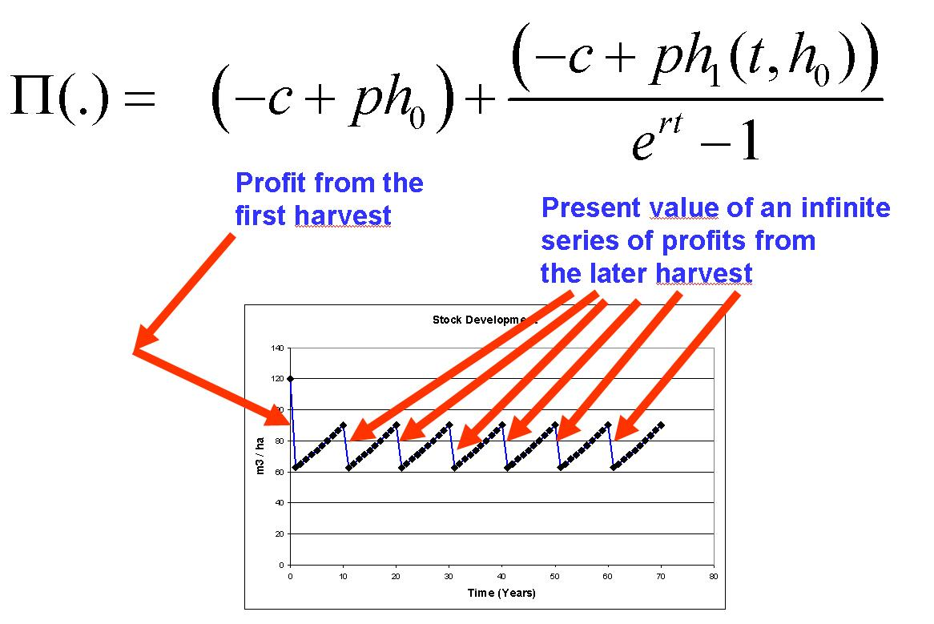

Figure 6.
The present value function, excluding the value of recreation, is the sum of the profit from the first harvest and the present value of the infinite series of profits from later harvests.
The cost of moving harvesters and forwarders to the harvest site is denoted c. p is the variable net profit per cubic metre. The harvest volumes during the first and later years are denoted h0 and h1 respectively. The rate of interest is r and the harvest interval is t.

Figure 7.
In case there are no people interested in recreation in the forest area and the objective is to maximize the present value of the profits of forest production, then we should follow the stock path described in the graph. Instantly after harvest, the stock level should be approximately 75 cubic metres per hectare. Then, we should harvest again, when the stock reaches 135 cubic metres per hectare. This means that we should use a ten year harvest interval.

Figure 8.
In case there are many people interested in recreation in the forest area and the objective is to maximize the present value of the profits from forest production plus the present value of recreation, then we should follow the stock path described in the graph. After harvest, the stock level should be approximately 45 cubic metres per hectare. Then, we should harvest again, when the stock reaches 165 cubic metres per hectare. This means that we should use a 22 year harvest interval.

Conclusions

In general, forest management, that is optimal when all objectives, including recreation, are considered, typically is characterized by larger thinning harvests than forest management that only focuses on the production of timber, pulpwood and energy assortments. It is important to be aware of the fact that the exact figures presented as optimized results are illustrations of typical expected cases. The detailed background and mathematical assumptions are reported by Lohmander and Zazykina [13].

The results also show that large set up costs have the same type of effect on optimal forest management as an increasing importance of recreation, close to large cities. Both of these factors imply that the harvest volumes, during each harvest, increase and that the time interval between harvests increases. Even rather small set up costs imply that the optimized continuous cover forest management schedule gives a rather large variation in the optimal stock level over time.

References:

[1] Lohmander, P., Continuous extraction under risk, IIASA, International Institute for Applied Systems Analysis, Systems and Decisions Sciences, WP-86-16, March 1986

[2] Lohmander, P., Continuous extraction under risk, SYSTEMS ANALYSIS - MODELLING - SIMULATION, Vol. 5, No. 2, 131-151, 1988

[3] Lohmander, P., Optimal resource control in continuous time without Hamiltonian functions, SYSTEMS ANALYSIS - MODELLING - SIMULATION, Vol. 6, No. 6, 421-437, 1989

[4] Lohmander, P., Continuous harvesting with a nonlinear stock dependent growth function and stochastic prices: Optimization of the adaptive stock control function via astochastic quasi-gradient method, in: Hagner, M. (editor), Silvicultural Alternatives, Proceedings from an internordic workshop, June 22-25, 1992,Swedish University of Agricultural Sciences, Dept. of Silviculture, No. 35, 198-214, 1992

[5] Lohmander, P., Optimal continuous harvesting with economies of scale and stochastic prices, Abstract,Solberg, B. (Editor), SCANDINAVIAN FOREST ECONOMICS, No. 37, 2001

[6] Lohmander, P., Optimal Continuous Cover Forest Management with Stochastic Prices and Set up Costs, INFORMS annual meeting 2004, Denver, Colorado, USA, Abstracts, http://www.informs.org/conf/Denver2004/

[7] Lohmander, P., Adaptive Optimization of Forest Management in a Stochastic World, in Weintraub A. et al (Editors), Handbook of Operations Research in Natural Resources, Springer, Springer Science, International Series in Operations Research and Management Science, New York, USA, pp 525-544, 2007 http://www.amazon.ca/gp/reader/0387718141/ref=sib_dp_pt/701-0734992-1741115#reader-link

[8] Lohmander, P., Mohammadi, S., Optimal Continuous Cover Forest Management in an Uneven-Aged Forest in the North of Iran, Journal of Applied Sciences 8(11), 2008 http://ansijournals.com/jas/2008/1995-2007.pdf, http://www.Lohmander.com/LoMoOCC.pdf
[9] Lu, F., Lohmander, P., Optimal Decisions for Mixed Forests under Risk, Scientia Silvae Sinicae, Vol. 45, No. 11, Nov. 2009
http://www.Lohmander.com/Lu_Lohmander_2009.pdf

[10] Lohmander, P., Zazykina, L., Rational and sustainable utilization of forest resources with consideration of recreation and tourism, bioenergy, the global warming problem, paper pulp and timber production: A mathematical approach, Proceedings of the II international workshop on Ecological tourism, Trends and perspectives on development in the global world, Saint Petersburg Forest Technical Academy, April 15-16, 2010
http://www.Lohmander.com/SPb201004/Lohmander_Zazykina_SPbFTA_2010.pdf
http://www.Lohmander.com/SPb201004/Lohmander_Zazykina_SPbFTA_2010.doc
http://www.Lohmander.com/SPb201004/PPT_Lohmander_Zazykina_SPbFTA_2010.ppt
http://www.Lohmander.com/SPb201004/PPT_Lohmander_Zazykina_SPbFTA_2010.pdf
[11] Zazykina, L., Lohmander, P., The utility of recreation as a function of site characteristics: Methodological suggestions and a preliminary analysis, Proceedings of the II international workshop on Ecological tourism, Trends and perspectives on development in the global world, Saint Petersburg Forest Technical Academy, April 15-16, 2010
http://www.Lohmander.com/SPb201004/Zazykina_Lohmander_SPbFTA_2010.pdf
http://www.Lohmander.com/SPb201004/Zazykina_Lohmander_SPbFTA_2010.doc

[12] Mohammadi Limaei, S. Lohmander, P. and Obersteiner, M. 2010. Decision making in forest management with consideration of stochastic prices, Iranian Journal of Operations Research, Vol.2, No.1, pp.32-40, http://www.Lohmander.com/LiLoOb2010.pdf

[13] Lohmander, P., Zazykina. L., “Methodology for optimization of continuous cover forestry with consideration of recreation and the forest and energy industries”, Forests of Eurasia, Moscow, 2010, Complete power point presentation with all derivations and graphs: http://www.lohmander.com/Moscow_2010/Lohmander_Zazykina_Moscow_2010.ppt

Preliminary version of summary in Russian:

Методология оптимизации непрерывного неистощительного
лесопользования, как для обеспечения рекреационных услуг, так и для переработки в лесной и энергетической промышленности.

Профессор Петер Ломандер
Шведский университет сельского хозяйства (SLU), 90183 Умео, Швеция
Электронная почта: peter.lohmander@sekon.slu.se

Леса используются и могут использоваться в разных целях. Важно учесть
все эти цели одновременно, разработан новый методологический подход к
оптимизации лесопользовании с учетом обеспечения рекреационных услуг, переработки в лесной и энергетической промышленности. Он
максимизирует общую текущую дисконтированную стоимость непрерывного неистощительного лесопользования и учитывает все затраты будущего периода и доходы, включая начальные затраты. В некоторых районах, в особенности вблизи больших городов, таких как Париж или Москва, экономическая важность рекреационного лесопользования очень высока, по сравнению с экономическими результатами полученными при традиционным лесопользовании. Однако, это не означает автоматически, что рациональное рекреационное лесопользование не может быть скомбинировано с производством пиломатериалов, целлюлозы и энергии. Согласно оптимизационной моделей, одной из составляющих является использование рекреационных услуг , которое может быть преобразовано в величину чистых доходов, от этих услуг и добавлено к традиционным целевым доходам от производства пиломатериалов, целлюлозы и энергии. В типичных случаях, предпочитаются леса под рекреацию с низкой плотностью насаждений, это означает, что лесопользование является оптимальным, когда учитываются все цели при осуществлении более частых рубок ухода в отличие от лесопользования, которое направлено только на производство пиломатериалов целлюлозы и энергии. Исследование показывает, что большие начальные затраты имеют такое же влияние на оптимизацию лесопользования, как увеличивающаяся важность рекреационных услуг в зонах близких, к большим городам. Оба этих фактора подразумевают, что объем вырубок на ед. времени увеличиваются , а так же увеличивается сам временной интервал между вырубками. Сравнительные малые начальные затраты означают что запланированное непрерывное неистощительное лесопользование дает относительно много вариаций оптимального уровня запаса древесины во времени.

