The utility of recreation as a function of site characteristics: Methodological suggestions and a preliminary analysis

Zazykina Liubov
Faculty of Forest Economics
Moscow State Forest University (MSFU)
Moscow region Mytischy – 5,
1st Institutskaya str. #1, Russia
e-mail: lyubovzazykina@rambler.ru

Professor Peter Lohmander
Department of Forest Economics,
Faculty of Forest Science,
Swedish University of Agricultural Sciences (SLU),
SE – 901 83 Umea, Sweden
e-mail #1: plohmander@hotmail.com
e-mail #2: peter@lohmander.com

Abstract:
The value of the utility of recreation is an important question in itself and also a necessary thing to understand in case we want to optimize forest management and connected activities. Forestry activities such as different kinds of harvesting change the characteristics of the forests. This, in turn, changes the utility of the individuals who visit the forest. It is obviously necessary to know exactly how the different characteristics of the forests influence the utility of the individuals during recreation. This paper gives a brief description of the present knowledge in this field, a presentation of important information that is not yet available and a method that hopefully will be useful in gathering the necessary empirical information that is needed in order to estimate the utility function of recreation as a function of stand characteristics.

Background
This paper gives a brief description of the present knowledge in this field, a presentation of important information that is not yet available and a method that hopefully will be useful in gathering the necessary empirical information that is needed in order to estimate the utility function of recreation as a function of stand characteristics.

Some examples of earlier research in the field
Bruce and Buhyoff (1986) developed a method which simulates and evaluates scenic beauty through time. The purpose was to obtain useful information for forest management and planning efforts. This is the function that they developed:
SB = 5.663 – 4.086 BA/t + 16.148 ln (BA), were SB – scenic beauty
BA – basal area per acre in square feet
t – stand age in years
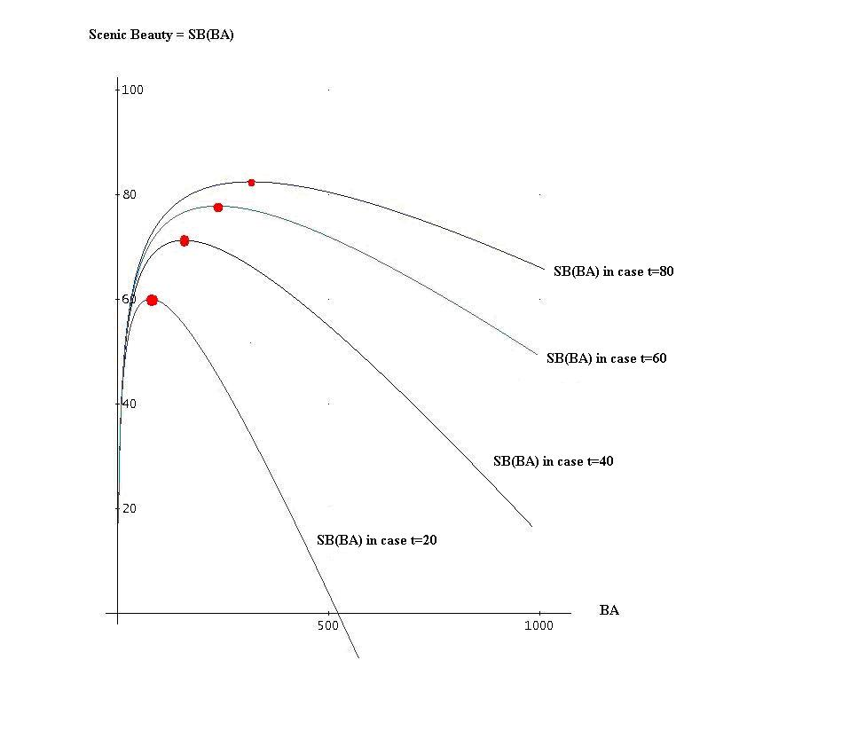
Figure 1.
Scenic Beauty, SB, as a function of basal area, BA. The graph has been constructed using equation SB = 5.663 – 4.086 BA/t + 16.148 ln (BA), which is found in Hull & Buhyoff (1986).

Hull and Buhyoff (1986) motivate the selected functional form this way:
Citation: “Model selection was also based upon the intuitive appeal of the predicted relationships (e.g., consistent with relationships found in past research; consistent with our expectations that relationships of this type may be nonlinear due to phenomena such as decreasing marginal utility; and, consistent with our expectations that interactions should exist among forest variables and their scenic impacts).” (End of citation.)
The authors of this paper are interested to develop and estimate a more general nonlinear utility model, without making any particular assumptions concerning interdependencies. The most general way is to estimate Taylor approximations of increasing degree, starting with second degree approximations. This way, the utility function will become quadratic. Such a function can become a part of a quadratic programming, QP, optimization problem definition. QP is a general optimization approach that can handle planning problems of very large size.

Examples of recreational forest areas
Here, we describe two plots in the Moscow region, one of them about 76 km from Moscow, "Alekseevskoye", and the other, approximately 35 km from Moscow, “Nikolskay dacha”. They have differences with respect to facilities, which will be described below. "Alekseevskoye" is located in the Sergiev Posad district. The total area of the recreational area is 37.6 ha, of which the forest area is 36.2 ha. Almost the whole area is composed of a mixed forest. Most of the species found are birch, aspen, alder and spruce.
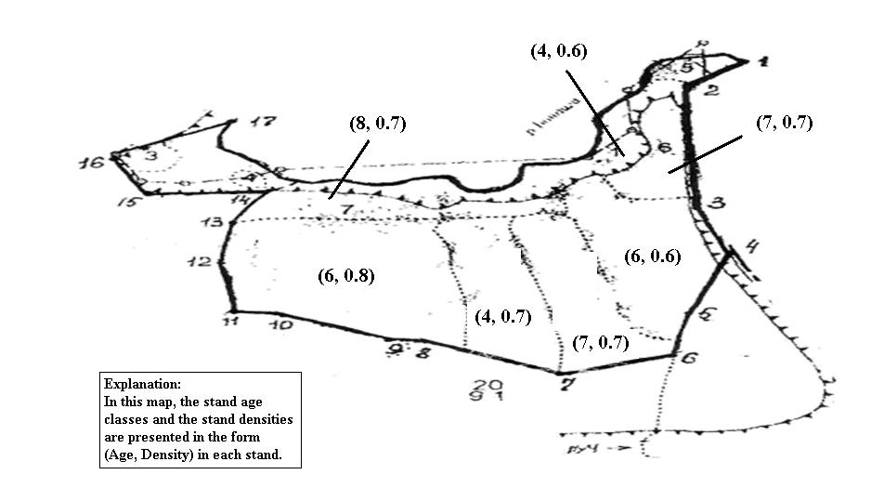
Figure 2.
“Alekseevskiy forest”

This area is of great value to people. As well as different types of mushrooms being found, there is a well developed path network and, additionally, there is a waterfall. It is called "Gremyachiy" - this is a unique monument of Nature, and its height is 25 m. According to the legend, a waterfall appeared at the same time as St. Sergius was praying. It is shaped like a chapel at the crevices, from which the water breaks, and there is a memorial sign on the bank of the river Lyapinki. The water has healing properties. There is a wooden staircase with a handrail made from twigs and roots. In all weathers, winter and summer, numerous pilgrims and tourists visit the area.
The other object of study ”Nicolskaya dacha” is located in the Schelkovskogo administration region. The total area is 2872 hectares. Almost the whole area is composed of a mixed forest. Most of the species found are Norwegian spruce (Picea abies (L.) Karst), Scots pine (Pinus silvestris L.), birch (Betula pendula Roth), aspen (Populus tremula L.). Furthermore, we can sometimes also discover oak (Quercus robur L.) and Siberian larch, (Larix decidua Mill).
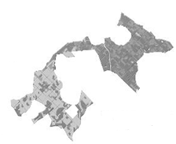
Figure 3.
Nicolskaya dacha.
”Nicolskaya dacha” is less important to tourism than the other plot, maybe because less people know about the history of this place. The first time we heard about this place, was in the sixteenth century. In 1846, the first forest plantation was made. In 1872 Nicolskaya dacha was bought by a manufacturing company. The owner understood that the forest was an important source for energy supply. This is why they managed the forest intensively. Since 1944, Moscow forest state university utilizes this area for scientific work, but this forest is also used for recreation. Earlier, before the peat was removed, the area contained two swamps. Now, the peat has been extracted and there are two nice lakes.

Questions and answers from visitors to the two forest recreation areas
As a result of the respondents answers to the questions about the preferences of the forest properties, we obtained the results presented in Tables 1. and 2.

Table 1. Preferences of tourists concerning the forest density and forest age in Plot 1.
Question | Which density would you prefer in Plot 1? |  |  | How old would you like the forest to be in Plot 1?
Answer | More density | Less density | Open area | 1-20 years | 21-49 years | 50-100 years | More than 100 years
Yes | 3 | 17 | 9 |  | 3 | 13 | 14
Could not answer | 1 |  |  | 0
Table 2.
Preferences of tourists concerning the forest density and forest age in Plot 2.
Question | Which density would you prefer in Plot 2? |  |  | How old would you like the forest to be in Plot 2?
Answer | More density | Less density | Open area | 1-20 years | 21-49 years | 50-100 years | More than 100 years
Yes | 5 | 16 | 11 |  | 11 | 10 | 8
Could not answer | 0 |  |  | 1

The tables show that the respondents prefer a low density forest to an open area, and an open area to a high density forest. If we sum the results from the two plots and make a standard regression analysis of the data, we get a function for the visitors preferences, found in Figure 4.

Figure 4.
Visitors preference, PREF, as a function of forest age, denoted t.
The preference data, plotted in Figure 4., can be described via this quadratic function:
The results in Figure 4. show that no respondent prefers to go to very young forest stands.
As we already explained, most people presently go to Plot 1, essentially because there are several well known historical aspects and objects at that site. These aspects are however of interest mainly for pilgrims.
For this reason, it is likely that large numbers of visitors with a more general touristic interest could be convinced to visit Plot 2. Then, the visitors would be more evenly distributed between the areas and everybody would probably benefit.
That is why we have decided to invite people to Plot 2. closer to Moscow. Of course they will spend less money on travel costs and Plot 1. will be less crowded.

Utility model
We are very interested in the question of how the characteristics of the forests influence the preferences of tourists to visit these recreational forests. To answer this question properly, we should use the characteristics of the area, courteously provided by the local forestry company and through questioning people. With that information, we can estimate a function of the following type, representing the utility of the visitor as a function of stand characteristics:

u= u₀ + u_{T} T+ u_{D} D + u_{TT} T² + u_{TD} TD + u_{DD}D² – α_{n}n – α_{k}k
where u - is the utility,
D – Stand density
T – Stand age
n – number of people in area per hectare
k – Total travelling distance to the area (back and forward)

Conclusion
It is obviously necessary to know exactly how the different characteristics of the forests influence the utility of the individuals during recreation. Here we have given a description of some essential parts of the present knowledge in this field, a presentation of important information that is not yet available and a method that hopefully will be useful in gathering the necessary empirical information that is needed in order to estimate the utility function of recreation as a function of stand characteristics. Two examples from Russia were examined and preliminary results obtained. The data from the example areas was used to estimate a model that will be useful when we intend to make comparisons between different areas. As the methodology is refined this data will be re-examined and more data obtained. Comparisons could then be made with other locations both within Russia and with other countries.

References

Arabatzis, G. & Grigoroudis, E. (2010) Visitors' satisfaction, perceptions and gap analysis: The case of Dadia–Lefkimi–Souflion National Park, Forest Policy and Economics, Vol. 12, Issue 3, March, pp. 163-172, http://dx.doi.org/10.1016/j.forpol.2009.09.008

Johansson, P-O (1987) The economic theory and measurement of environmental benefits, Cambridge University Press, Cambridge, UK

Hull IV, R.B. & Buhyoff, G.J. (1986) The Scenic Beauty Temporal Distribution method: An Attempt to make Scenic Beauty Assessments compatible with forest planning efforts, Forest Science, Vol. 32, No. 2, pp. 271-286

Personal communication:
Melnik, P.G. (2008) Nikolskaya dacha, Moscow State Forest University, Moscow

From the lease (document) of the forest plan

